

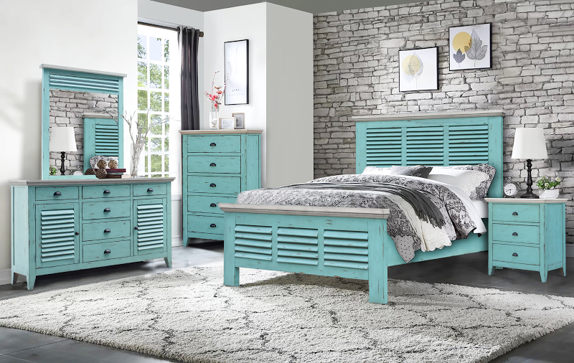

Made with solid timber, the Rosalyn is special. The slatted elements suggest a free-flowing breeze. The color, a beautiful shade of ocean water, completes this group’s relaxing, casual look, making it easy to shirk the burden of a busy workday. With all the usual case goods, this set is suited well for master bedrooms and guestrooms. It’s what you’ve come to expect from Cottage Creek - unique style and unmatched durability.

High Point Showroom: Warehouse:
The Profit Center 3415 Hwy 53
156 S Main St. Huntsville, AL 35806
Show Phone Number: Office Phone Number:
561-339-1268 256-852-9777

