

Dressing Your Beds to Make Your Registers Ring

Join us at HiEnd Accents showroom in Showplace #3425 on October 20th at 2pm.

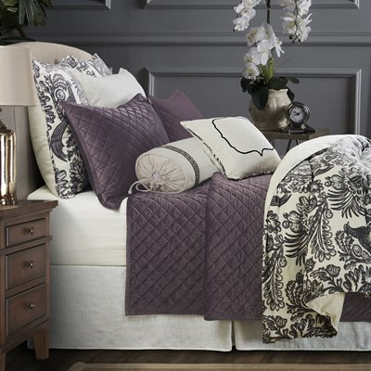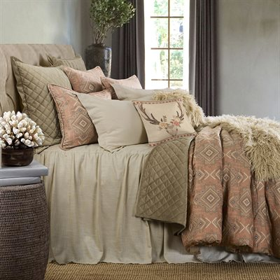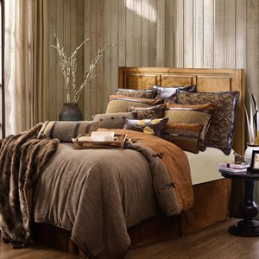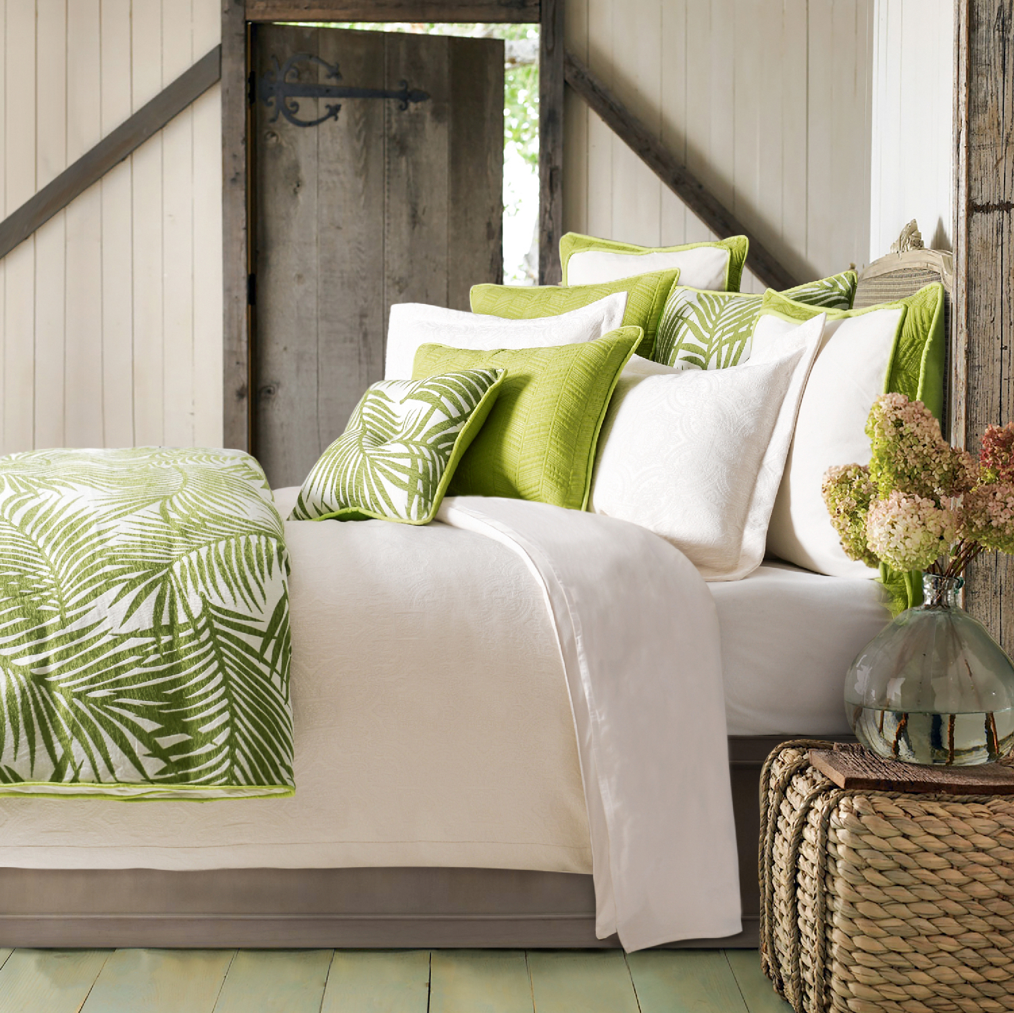

At this special event, HiEnd Accents will show you how to dress up and accessorize your bedding displays to get the most out of your floor space.

Statistics show, furniture and lifestyle stores that create home like vignettes sell more and generate more profit per square foot. Stores that do display like this look more interesting and stimulating which allows customers to better visualize the furniture in their home. Beautiful fabrics and textures can elicit emotions, excitement and build value.

Highlights of the event:

- How to get Designer looks at department store pricing.
- Allow your customers to spend more money with you, keep their dollars in house.
- Customizing and building collections specific to your store and customer.
- Easy to follow, distinctive design trends.
- Creating a complete lifestyle look in your store.
- How to generate frequent repeat business.
- Tricks of the trade, and how to make your registers ring!

HiEnd Accents are experts in working with furniture stores. We are flexible in helping you meet your customer’s needs. At HiEnd Accents, our designers and sales representatives can assist you to accessorize your mattress with affordable luxury top of bed linens and accessories for add-on sales. Check out our website www.hiendaccents.com or contact a Sales Representative at sales@hiendaccents.com.

