Name: Scott McKearn
IHFC IH302
Phone Number: 512-468-3443
Email: scott@domedeco.us

High Point, NC –

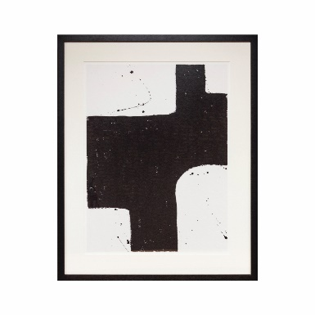
Code: EF408
Description: Wall Art Ivan Melotti Ii. Pairs with the Ivan Melotti l for a monochromatic study of shape & contrast.
Dimensions: 33.5" L x 41.3" W x 2.8" H
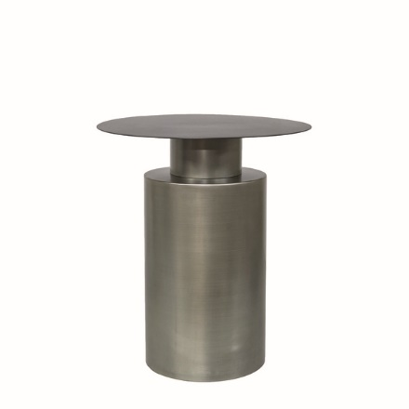
Code: F10-S13/BLA
Description: Side Table With Light Grey Zinc Base made in Poland. 1 of 20 source countries leveraged to create the Dôme Deco Cosmopolitan Living Collection. Available in two finishes.
Dimensions: 18.1" D x 20.1" H
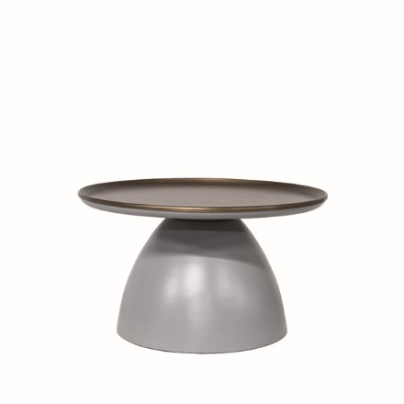
Code: F11-S2/BRO
Description: This stylish round Coffee Table With Grey Base was made in Poland. 1 of 20 source countries leveraged to create the Dôme Deco Cosmopolitan Living Collection.
Dimensions: 24.8" D x 14.0" H
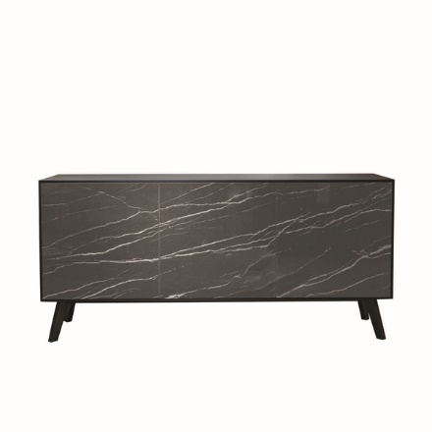
Code: F13-W24/BLA
Description: Thundernight Gloss Ceramic Front Buffet/Media Stand. Made in Italy. 1 of 20 source countries leveraged to create the Dôme Deco Cosmopolitan Living Collection.
Dimensions: 70.9" L x 18.5" W x 31.5" H

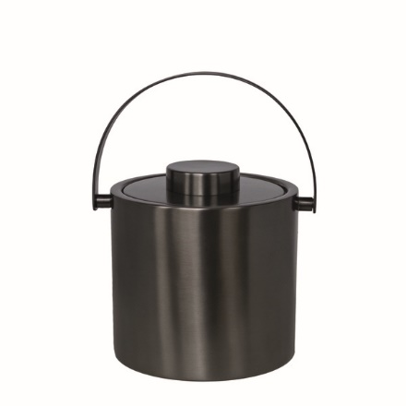
Code: K3-S5/AN
Description: No Cosmopolitan Living bar is complete without this contemporary gem of an Ice Bucket.
Dimensions: H: 31” x W: 31” x D: 28”

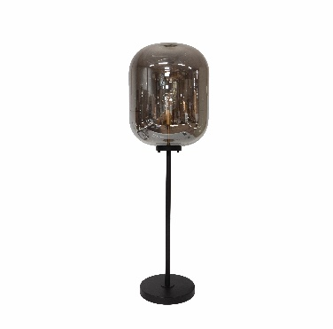
Code: L2-G3/BLA
Description: Medium Glass Metal Base & Led Bulb Floor Lamp. Smaller version also available
Dimensions: 13.8" D x 66.9" H
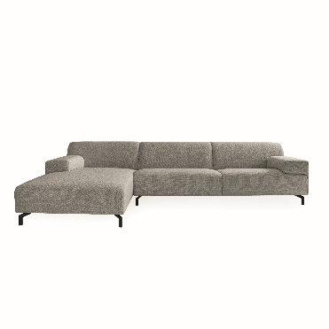
Code: LUG160-330/BR60
Description: Lugano L-Couch With Brema Fabric made in Poland. 1 of 20 source countries leveraged to create the Dôme Deco Cosmopolitan Living Collection.
Dimensions: 63.0" L x 129.9" W x 30.3" H
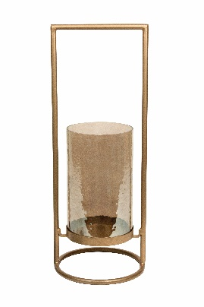
Code: T3-S95/GO
Description: Candle Holder, Hammered Glass
Dimensions: 9.8" L x 8.3" W x 22.0" H

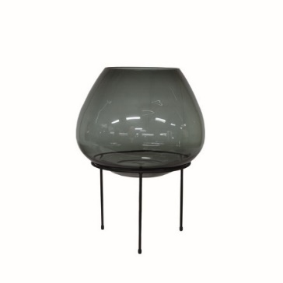
Code: V2-G456/GRI
Description: Vase Cold Cut Glass On Black Stand Medium. Multiple Sizes & Hues of Glass Available.
Dimensions: 17.3" D x 23.2" H

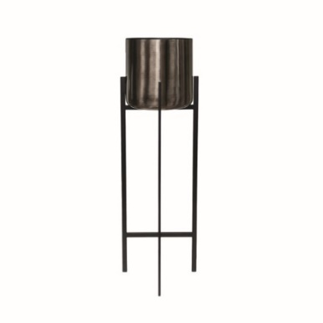
Code: V3-A8/BRO-BLA
Description: Aluminum Vase/Planter On Black Iron Stand is a new Dôme Deco Signature Item.15.4" D x 51.2" H. Also available 11.8" D x 43.3" H

Dôme Deco is a leading European Lifestyle and Home Furnishings brand that distributes a cosmopolitan interior concept consisting of furniture, home accessories, lighting and textiles.

“We have earned a unique place in homes, through retailers and in projects worldwide. With our launch in the U.S. in January 2019, we are thrilled to make this wonderful collection available here in the States”, says Dôme Deco-US Owner Sangeeta Gupta.

Cosmopolitan Living
Cosmopolitan living, two words that capture everything Dôme Deco stands for. We create interior collections with a cosmopolitan identity. Our strong desire to explore and gather inspiration from all over the world is translated in collections that are recognized by unique combinations of colors and textures. This results in a warm, inviting and sophisticated interior atmosphere. An interior look suited for those who enjoy an urban lifestyle with a touch of luxury.

###

