Maxwood’s second Vietnam facility will again triple production capacity

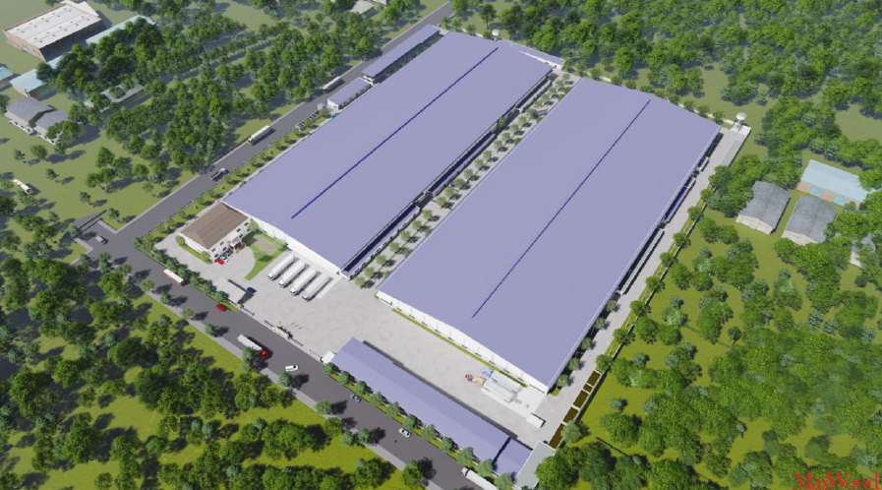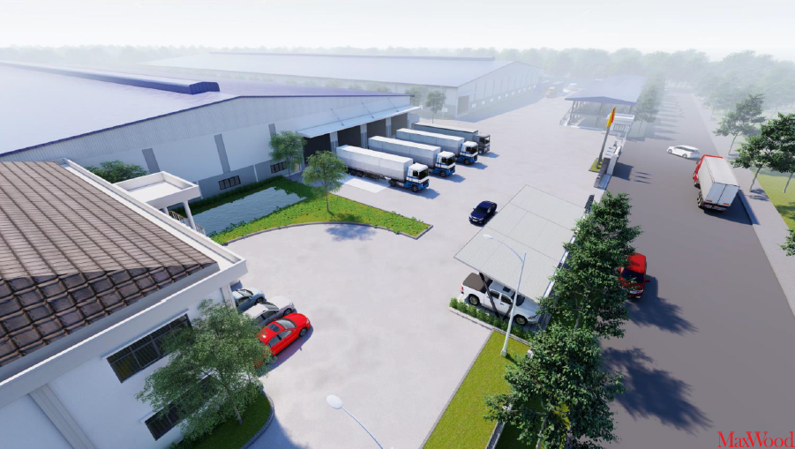

Maxwood has broken ground on a new 600,000 sq ft Maxwood factory that will triple production capacity, starting March 2021. This new factory will also be fully accredited, with the latest equipment & maintain Maxwood’s focus on quality, safety & value.
Maxwood has been manufacturing wood furniture products in Vietnam for over ten years. It’s just 2 years since Maxwood announced the opening of their new 200,000 sq ft factory, enabling the expansion of youth lines, diversification into Master Bedroom Collections & expanded custom manufacturing capabilities. Since then Maxwood has continued to go from strength to strength, building on its solid reputation for quality & precision engineering. Fast forward to 2020 and Maxwood has again outgrown its plant capacity due to strong demand.
“It is very exciting for us because our manufacturing capacity was becoming a pain point, and the new facility allows us to again significantly expand our volume.” Anne Jensen (CMO, Maxwood Furniture) said of the new facility. “We feel incredibly lucky to have experienced no major interruptions in factory or warehouse operations throughout 2020, and this new factory will give us the opportunity to further expand into new categories, styles and finishes, and serve our customers into 2021 and beyond” she said, noting that Maxwood finances the operation and controls all production.
The new factory will also have a showroom that customers can visit to see new product, a huge plus given that Maxwood is doing a lot of private label & custom manufacturing. And while travel restrictions remain in place, Maxwood is using creative ways to keep customers informed on design & production, using images & videos in addition to shipping samples direct to customers for review & sign-off.
Another way Maxwood is staying connected is by actively sharing company news on its LinkedIn page, in addition to offering both in person & virtual tours of their High Point showrooms. “Customer satisfaction is of upmost importance to us, so staying connected, especially during these challenges times, remains a priority!” said Peter Schlunssen – Global Sales Manager.
Maxwood is exhibiting this High Point fall market October 13th – 20th; Center Point on Hamilton, 401 S. Hamilton Street High Point, NC 27260 (showrooms 222 & 226). To learn and make an appointment please contact Peter at 203.916.2075 or pvs@maxwoodfurniture.com or submit an online enquiry http://www.maxwoodfurniture.com/dealer-information

