New Growth Designs Announces Handmade Orchid Addition To Flowerscape Lineup

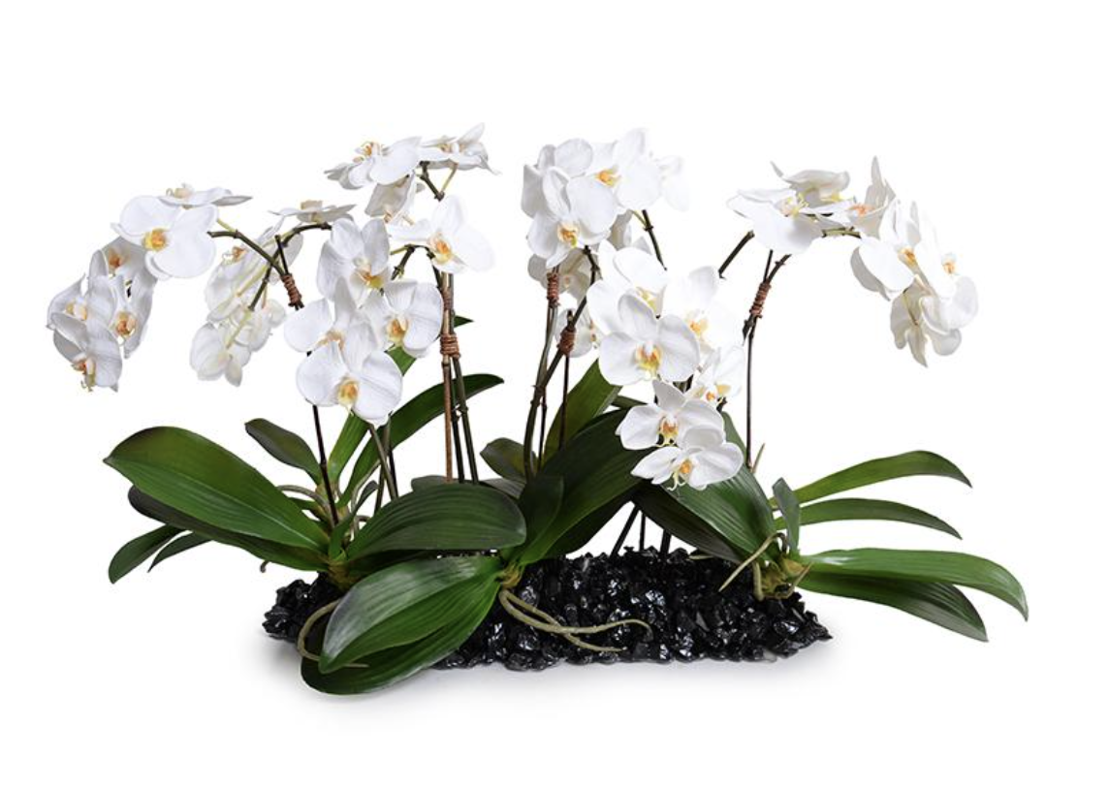
Greenville, NC - New Growth Designs announces the introduction of its latest orchid Flowerscape design. Set to debut at the fall 2020 High Point Market, this lifelike arrangement includes multiple stems of the Phalaenopsis orchid, one of New Growth Design’s leading sellers. This introductory centerpiece will feature a base of natural ebony small stones.

Handmade in the USA by the New Growth Designs artisans, the Phalaenopsis Orchid stone-enhanced table runner offers a unique option for customers looking for a centerpiece that highlights a natural installation.

This new orchid centerpiece can be displayed directly on any surface eliminating the need for a container or vase. The Phalaenopsis Orchid design, available in white, is set to be introduced to retailers and designers during the fall 2020 High Point Market at the New Growth Designs showroom - 422 North Hamilton Street – Red Line Bus, Stop 20.

“Our customers look to us for unique and creative designs,” said Ed Glenn, owner, New Growth Designs. “With this elegant addition to our realistic orchid line, our team once again has been able to provide just that.”

For more information about New Growth Designs contact sales@newgrowthdesigns.com or
252-752-6195.

# # #
EDITORIAL ASSETS: Click here for word doc and images.

About New Growth Designs.
New Growth Designs, a family-owned business, remains committed to being the best resource for permanent botanicals. Started by floral artist, Ed Glenn, the primary mission of New Growth Designs was to be a source for incredibly lifelike permanent botanicals with each stem, leaf and bloom exhibiting natural beauty. Constructed in the USA by true artisans, each product incorporates the finest in materials including proprietary Enduraleaf® and Durt® elements. www.newgrowthdesigns.com

