New Growth Designs Introduces Updated Styling For Magnolia Leaf Wreaths

Greenville, NC – New Growth Designs, proudly introduces an update to its popular 28” and 22” Magnolia leaf wreaths available for immediate shipment. Hand built by the artisans at New Growth Designs, the new designs include a flowing leaf arrangement in one direction to enhance the realism of this top selling wreath. Set to debut at the fall 2020 High Point Market, the new wreath designs are set to be introduced to retailers and designers at the New Growth Designs showroom - 422 North Hamilton Street – Red Line Bus, Stop 20.
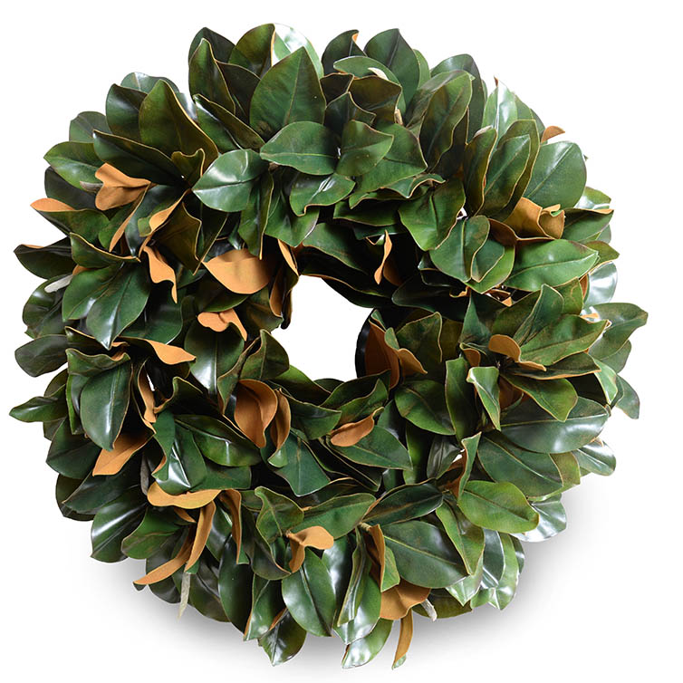
Just in time for the holidays, this interior or protected space wreath design has more realistic leaves than ever with a single direction arrangement. The Faux Fresh® Magnolia leaves used in these products have a bright, glossy green finish on the top and a golden suede finish on the underside for a real Magnolia look and feel. Featuring 258 leaves, the 28” diameter wreath is 8" deep, and has a 6" center opening. The 22” wreath features 126 leaves.

The design accommodates the placement of fresh cut branches arranged into each wreath to allow for seasonal dressing. With an ability to last in a protected, non-direct sunlight, location, this wreath can be on display for multiple seasons.

“Our design team is always looking to improve and enhance our designs,” said Ed Glenn, owner, New Growth Designs. “That is evident in this update to one of our best-selling wreaths as they addressed a way to make it more realistic and stylish.”

For more information about New Growth Designs contact sales@newgrowthdesigns.com or
252-752-6195.
# # #

EDITORIAL ASSETS: Click here for word doc and images.
About New Growth Designs.
New Growth Design, designer and manufacturer of fine faux flowers, plants and trees for the design trade is a family-owned business committed to being the best resource for permanent botanicals. Started by floral artist, Ed Glenn, the primary mission of New Growth Designs was to be a source for incredibly lifelike with each stem, leaf and bloom exhibiting natural beauty. Constructed in the USA by true artisans, each product incorporates the finest in materials including proprietary Enduraleaf® and Durt®.

