New Growth Designs Announces Expansion of Fiddle Leaf Fig Collection

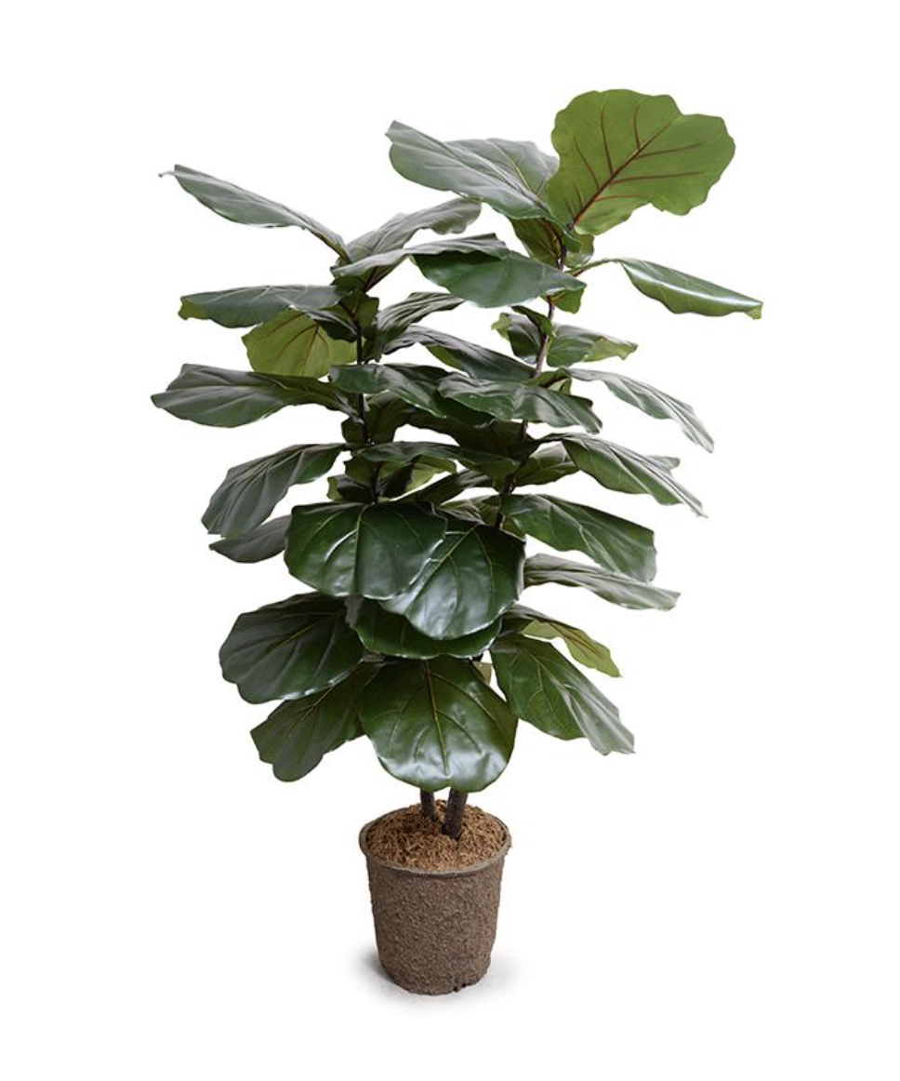
Greenville, NC – For 2020, New Growth Designs, proudly introduces the latest additions to its popular line of Fiddle Leaf Figs. To debut at the Fall High Point Market are a 64” large broad leaf design offering a bold and authentic statement and a 6.5’ Fiddle Leaf Fig sized to accommodate rooms with a traditional 8-foot ceiling. Each Fiddle Leaf Fig design incorporates a thick canopy of realistic green leaves of varied sizes. Retailers and designers will be able to view the new introductions during the fall 2020 High Point Market at the New Growth Designs showroom - 422 North Hamilton Street – Red Line Bus, Stop 20.

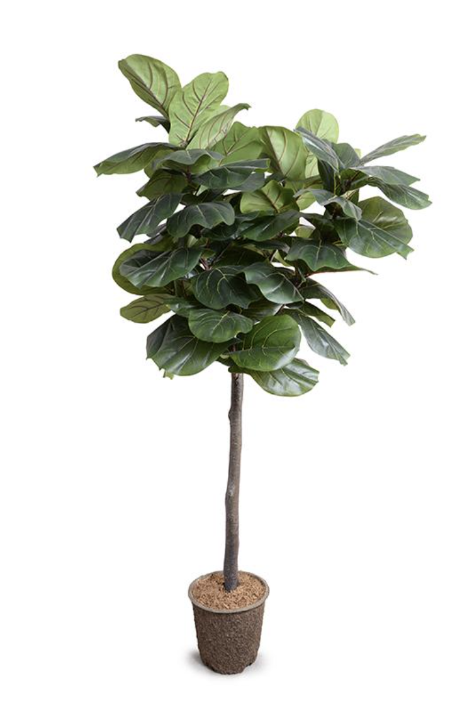
Handmade by the artisans at New Growth Designs, the full 64” broad leaf Fiddle Leaf Fig design incorporates the company’s signature high quality construction and materials. The versatile height of just over five feet offers an updated style for interior spaces. The mache pot base design easily accommodates planters, baskets or desired display elements.

The new 6.5’ design Fiddle Leaf Fig has been added to fill a need acknowledged for realistic designer greenery built to easily enhance rooms with traditional 8-foot ceilings. The hand-made 6.5' single-trunk Fiddle Leaf Fig tree features a lush array of realistic and varied size green leaves. With overall dimensions of 36”L x 36”W x 78”H, this tree incorporates similar color, leaf shapes and construction as other larger designs in the Fiddle Leaf Fig tree collection.

For more information about New Growth Designs contact sales@newgrowthdesigns.com or
252-752-6195.
# #
EDITORIAL ASSETS: Click here for word doc and images.

About New Growth Designs.
New Growth Designs, a family-owned business, remains committed to being the best resource for permanent botanicals. Started by floral artist, Ed Glenn, the primary mission of New Growth Designs was to be a source for incredibly lifelike permanent botanicals with each stem, leaf and bloom exhibiting natural beauty. Constructed in the USA by true artisans, each product incorporates the finest in materials including proprietary Enduraleaf® and Durt®.

