New Growth Designs Introduces Haybasket Designs Featuring Succulent and Stem Additions

Greenville, NC – New Growth Designs, designer and manufacturer of fine faux flowers, plants and trees for the design trade, proudly introduces its Haybasket designs augmented by the debut of numerous life-like succulents, sprays and stems. Made of New Growth Designs’ exclusive Enduraleaf®, the seven latest sprays range from Gysophila to Baby Jade with each built to hold up in outdoor weather conditions for years of use. Additional sprays can also be incorporated into the Haybaskets to provide pops of color and textures. The new Haybasket designs and Enduraleaf® stems and sprays are set to be introduced to retailers and designers during the fall 2020 High Point Market at the New Growth Designs showroom - 422 North Hamilton Street.

Included within the seven new Enduraleaf® stems is the Gypsophila, “Baby Breath,” in a bright violet color at a full 25.5” in height. The Herb Grass stem will join the outdoor durable collection with needle-like bright green leaves on multiple stems. It is a full 17.5” accent spray perfect for adding to the Haybasket as well as other faux plantings.

The 16” Berry Branch also will join the Enduraleaf® collection with bright red-green berries adorning this 16-inch stem. A fade-resistant Brunia stem, a 9-inch-long deep purple pick, will be introduced designed to add lasting color to basket designs. An outdoor arborvitae branch, made of Enduraleaf ® polymer, also set to debut, features realistic greenery and berries on a 33-inch brown branch.

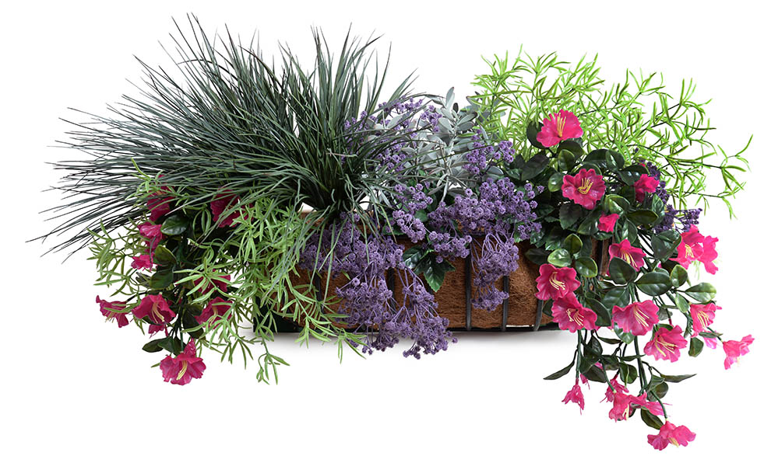
The new outdoor boxwood shrub branch debuting is made of bundles of leaves constructed of durable Enduraleaf® on a 30-inch stem. Also, within the additions to the Enduraleaf® spray collection is a popular succulent, Baby Jade. This realistic 14" long, dark succulent stem can add dimension to bouquets or arrangements, or mixed faux succulent gardens.

For more information about New Growth Designs contact sales@newgrowthdesigns.com or 252-752-6195.
# # #

EDITORIAL ASSETS: Click here for word doc and images.
About New Growth Designs.
New Growth Design, designer and manufacturer of fine faux flowers, plants and trees for the design trade is a family-owned business committed to being the best resource for permanent botanicals. Started by floral artist, Ed Glenn, the primary mission of New Growth Designs was to be a source for incredibly lifelike with each stem, leaf and bloom exhibiting natural beauty. Constructed in the USA by true artisans, each product incorporates the finest in materials including proprietary Enduraleaf® and Durt®.

