New Growth Designs Expands Enduraleaf® Collection By Adding Holiday Wreaths

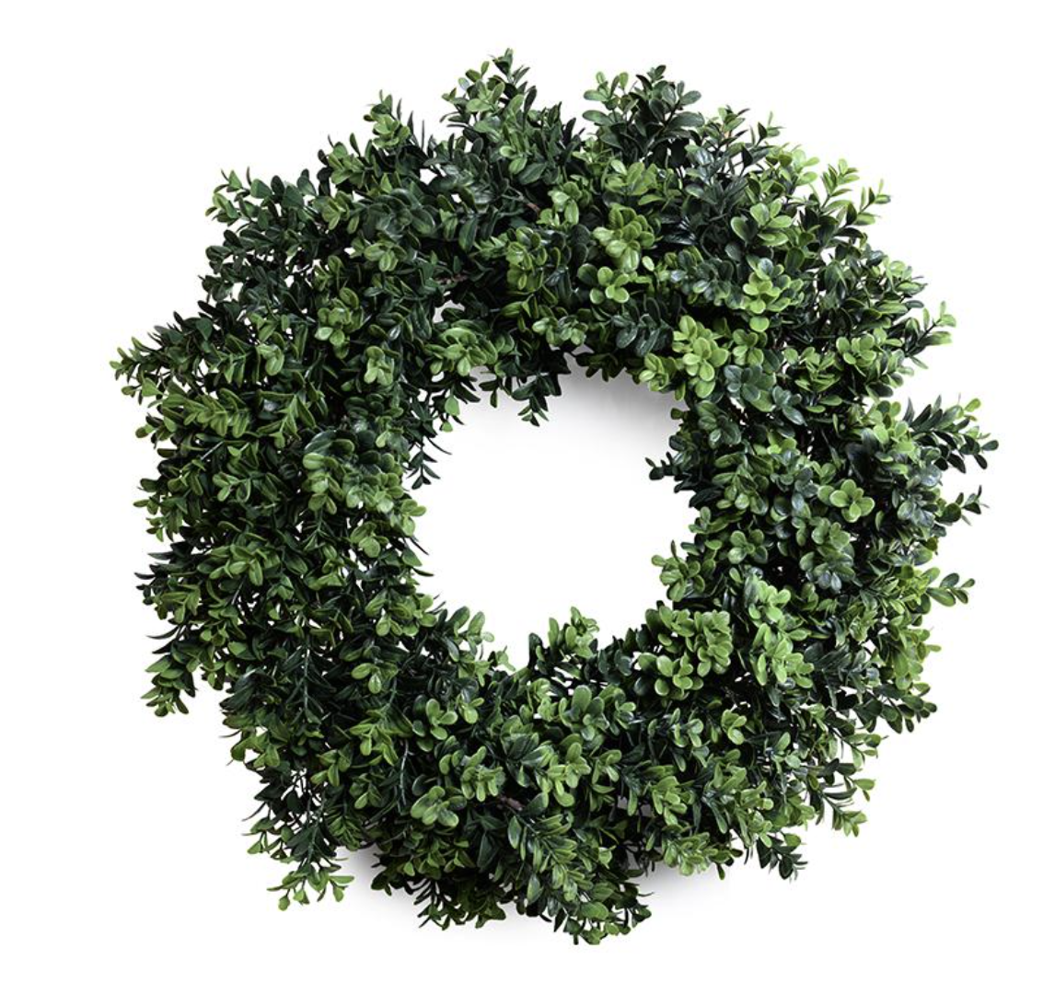
Greenville, NC – New Growth Designs, designer and manufacturer of fine faux flowers, plants and trees for the design trade, proudly introduces the latest additions to its outdoor-durable Enduraleaf® collection with Boxwood Enduraleaf® Holiday Wreaths. Debuting are 28” and 22” diameter wreaths each handcrafted to be used outdoors not only during the holidays, but year-round. The weather-resistant Boxwood wreaths are set to be introduced to retailers and designers during the fall 2020 High Point Market at the New Growth Designs showroom - 422 North Hamilton Street – Red Line Bus, Stop 20.

With a classic Boxwood leaf style, these new wreaths offer added innovation and durability through an Enduraleaf® construction. In a dense circular mass of shrub branches, the two wreath designs measure 28” and 22” in diameter with a depth of 5”. The openings within the wreaths measure 10” in the 28” design and 8” in the 22” style. The two-toned green foliage of Enduraleaf® is handcrafted to stand up to years of outdoor use. Both designs coordinate with New Growth Design’s 6-foot Enduraleaf® Garland.

First designed in 2019 to offer practical solutions for challenging growing situations and environments, Enduraleaf’s durability represents advances in product engineering by New Growth Designs. Enduraleaf® products carry a 5-Year Limited Warranty based on accelerated weathering tests lasting more than 7,000 continuous hours.

For more information about New Growth Designs contact sales@newgrowthdesigns.com or 252-752-6195.

# # #
EDITORIAL ASSETS: Click here for word doc and images.

About New Growth Designs.
New Growth Design, designer and manufacturer of fine faux flowers, plants and trees for the design trade is a family-owned business committed to being the best resource for permanent botanicals. Started by floral artist, Ed Glenn, the primary mission of New Growth Designs was to be a source for incredibly lifelike with each stem, leaf and bloom exhibiting natural beauty. Constructed in the USA by true artisans, each product incorporates the finest in materials including proprietary Enduraleaf® and Durt.

