New Growth Designs Announces New Arborvitae Shrubs Added To Popular Enduraleaf® Collection

Greenville, NC – New Growth Designs’ popular Enduraleaf® Collection expands once again with the addition of new Arborvitae Shrubs in 32” and 30” sizes. Constructed for long life in the out-of-doors, these new Enduraleaf® products feature dense green foliage with spring green tips and green berries in two unique designs. The lifelike Arborvitae Shrubs will be introduced to retailers and designers during the fall 2020 High Point Market at the New Growth Designs showroom - 422 North Hamilton Street.
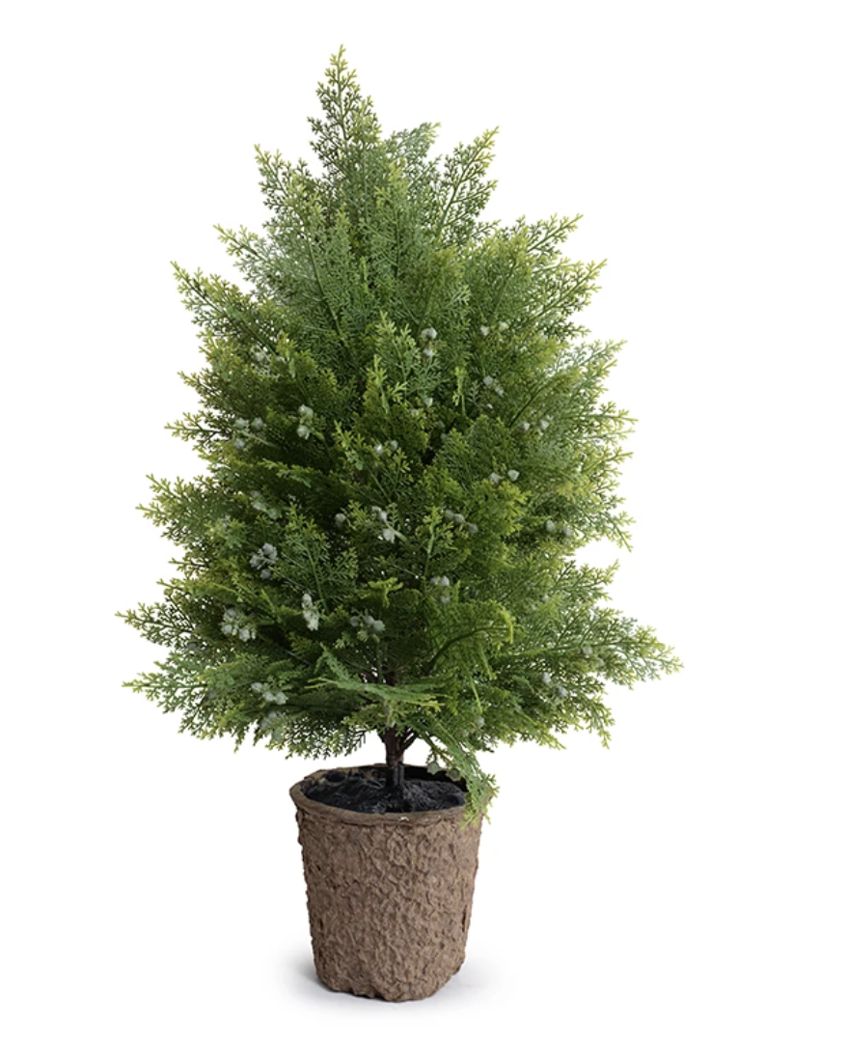
The new Arborvitae shrubs of Enduraleaf® are realistic options for adding lasting greenery to challenging outdoor spaces. Due to a weather-resistant construction, the maintenance-free plants can provide flexibility in exterior landscaping and patio-scape designs.

Each of these new introductions are created of lush overall foliage. The 32” shrub is naturally shaped to a slender peak while the 30” shrub features a fuller and more rounded profile. At 20”L x 20”W x 32”H or 14"L x 14"W x 30"H, these Enduraleaf® faux botanicals are completely UV-stabilized.
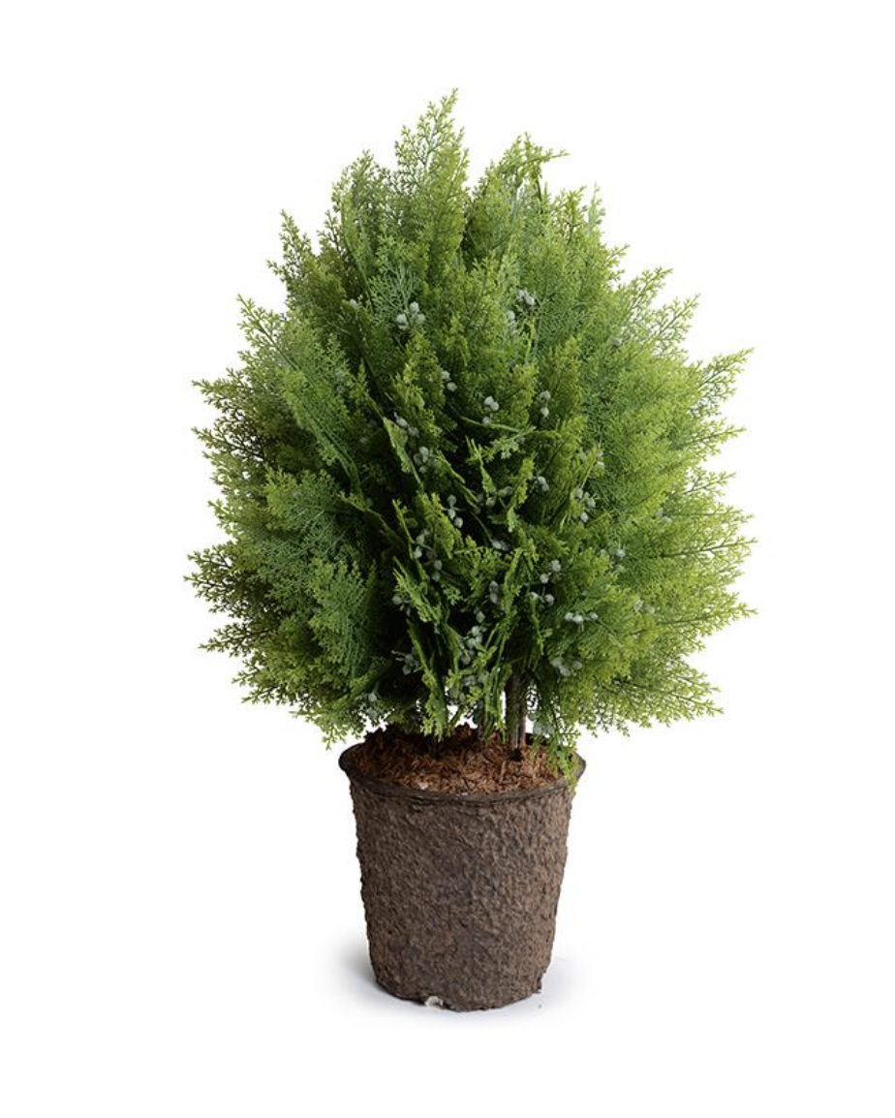
First designed in 2019 to offer practical solutions for challenging growing situations and environments, Enduraleaf’s durability represents advances in product engineering by New Growth Designs. Enduraleaf® products carry a 5-Year Limited Warranty based on accelerated weathering tests lasting more than 7,000 continuous hours.

For more information about New Growth Designs contact sales@newgrowthdesigns.com or 252-752-6195.

# # #
EDITORIAL ASSETS: Click here for word doc and images.

About New Growth Designs.
New Growth Design, designer and manufacturer of fine faux flowers, plants and trees for the design trade is a family-owned business committed to being the best resource for permanent botanicals. Started by floral artist, Ed Glenn, the primary mission of New Growth Designs was to be a source for incredibly lifelike with each stem, leaf and bloom exhibiting natural beauty. Constructed in the USA by true artisans, each product incorporates the finest in materials including proprietary Enduraleaf® and Durt®.

