Classy Art Partners with Million Meal Movement to Fight Hunger
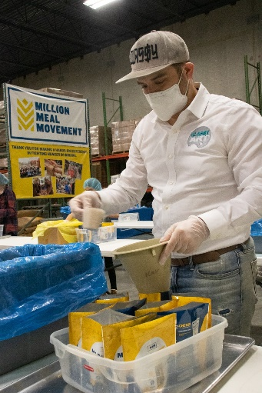
Houston, TX Feb 5, 2021- Premier wholesale wall art and décor supplier Classy Art, LLC is proud to announce a partnership with the Indianapolis-based Million Meal Movement in their effort to provide nutritious meal packages to food pantries. Gabriel Cohen, CEO and President of Classy Art, said he was inspired around the holidays last year to come up with a way for his company to give back and make a tangible difference in 2021 and beyond.
Knowing that food poverty is an ongoing concern, exacerbated as the global health crisis continues into the new year, Cohen went on the hunt for an organization that aligned with Classy Art’s grassroots values and where their donation dollars could be maximized. He found a perfect match in the Million Meal Movement, a group that focuses on fighting hunger while encouraging volunteerism and activism. As a result of this partnership, Classy Art has committed to providing one meal to a hungry American child for every single unit sold. Wishing he started this last year, Cohen says they would have provided over 77,000 meals, but with his aggressive growth goals he intends to supply over 100,000 meals in 2021 alone and many more in the years to come.
Classy Art, LLC CEO and President Gabriel Cohen measures out pasta for macaroni & cheese dinners at a Million Meal Movement packing event.
“With Million Meal, our donation can be far more important than just another number on a page,” Cohen said, “And it’s a small, independent movement. We liked that they were young like us, we liked their vibe, what they stood for, and definitely the impact they are making.”
The Million Meal Movement was founded in 2007 and is based on two principles feeding the hungry and providing opportunities for volunteers to be directly involved in the process. They hold community packing events, where people of all ages can come together to help nourish their neighbors. Since the group’s inception, the Million Meal Movement has donated nearly 31.5 million meals to fellow Americans by stocking food pantries and banks around the state with pre-packaged boxes of nutrient-rich staples. Classy Art is working with the movement to see that their donations go towards assisting children, and Cohen is excited to see their contributions in action.
“Million Meal is keeping us very involved in the process,” the wall décor manufacturer said, “They asked us how we wanted the funds allocated, and we indicated that we want to make sure we’re helping children. With our donations, they’re going to take the materials to a school where students will volunteer to package the meals that will be going directly to that same school and neighboring schools in need of help.”
The overwhelming statistics about hunger and food poverty nationwide mean that Million Meal’s mission and Classy Art’s support are timelier than ever. It’s estimated that one in every five children in America suffers from food insecurity, and that number has been steadily on the rise.
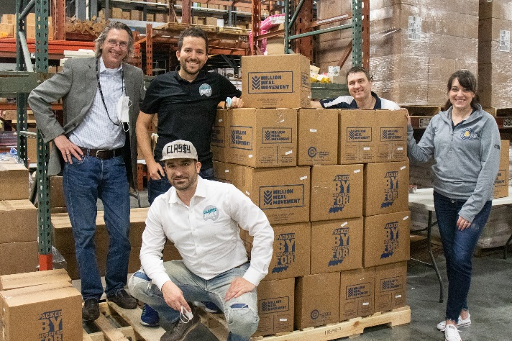
Members of the Classy Art team were recently able to join a live Million Meals packing event, and Cohen said the experience was unique. He explained that the events function as a cooperative project to package large quantities of food efficiently.
“Volunteers work together to package a Macaroni & Cheese Dinner or Rice Soy Casserole, for example, “Cohen said, “These nutritious, shelf-stable meals are easy for recipients to prepare, require no extra ingredients aside from water, and feed four individuals. They are fortified, too, so that kids get the nutrition they need. The macaroni and cheese, for example, has added Vitamin D and calcium.”
Classy Art LLC’s CEO Gabriel Cohen, CFO Johnathan Cohen and Indiana Sales Rep PJ Lenfert join the Million Meal Movement’s Shane Scarlett and Kaila Dickinson for a meal-packing event in Indiana.

Cohen hopes that Classy Art’s involvement with the Million Meals Movement will inspire other businesses to find new connections and take a stand against hunger and other societal issues.
“We aim to feed as many children as we can, but that’s not the only mission,” Cohen said, “We have a core focus at Classy Art (aka mission statement), and that’s to ‘aspire, inspire, and create life-long relationships.’ Our main mission is to inspire other organizations to use their power to help those in need. I fear that our culture is too focused on earning profits, but we should have a shared sense of responsibility for the greater good of our community.”
Cohen and the Classy Art team stand firmly behind their own mission and the mission of the Million Meals Movement to conquer hunger through the power of community. And while Cohen is proud of his business’s success, he knows there is always something more to being an industry leader than profits and the bottom line.
“Money’s great,” he said, “But it’s not a reason to be live your life. I feel that this partnership not only gave meaning and purpose to me as an individual, but it has inspired our entire staff from upper management all the way to our warehouse personnel.”
More About Classy Art: Classy Art is a leader in the wall art/decor field catering specifically to furniture retailers across the country. Their average growth of 50% per year is the result of products that have proven to sell faster at retail through their proprietary process of product research. This higher rate of sale has increased customer retentions as well as new customer acquisition. The company carries all subcategories of wall décor including framed prints, metal, clocks, canvas, tempered glass, and mirrors, and they pride themselves on single week lead times and guaranteed inventory. For more information visit www.ClassyArt.net.
Anyone wishing to learn more about the Million Meal Movement and how they can get involved should go to the organization’s webpage at, found at www.millionmealmovement.org, to read their story and see the scope of Million Meal’s impact across their home state of Indiana.

