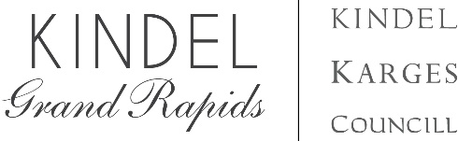
Kindel Grand Rapids to Introduce Facets Work from Home

FOR IMMEDIATE RELEASE Grand Rapids, Michigan May 1, 2021 – Kindel Grand Rapids is pleased to announce the expansion of their Facets program to include ‘Work from Home’ category products. The additions add to the program consisting of configurable chests and credenzas, bedroom, dining, occasional and bar products.
The program will bring a range of luxury options to work at home products this June. The additions to the collection will include table desks, bookshelves, file cabinets and a new mobile work unit/occasional table named the Multi-Facet. Each of these are unique pieces, pull from components and parts from the Facets chest and credenza program, an important aspect of Facets.
Facets has broad appeal because of the range of luxury choices, especially with the chest, credenza and nightstand products. The new work from home products offer options including hand painted fine lines, multiple species options, dual finishes, and 68 hand rubbed wood and paint finishes. The finishes include a collection of artistic, hand applied finishes that showcase the multi-step finishing process that is prized within Kindel Grand Rapids brands.
Kindel Grand Rapids is known for craftsmanship at the highest level and made in the USA. The company’s streamlined process combined with efficiencies of design, enables lower opening price points. “Our discussion with designers, end-users, and through our own experimenting with various product prototypes, led us to an offering that supports the end-user as she works and enjoys entertainment and dining in her home. We have blurred the line between work at home functionality and luxury in design., We have also delivered attractive pricing,” states Rob Burch, president and CEO.
The Facets Collection additions are launching at the June, 2021 High Point Market beginning Friday, June 4, and will be available to view in person at the Kindel Grand Rapids showroom in High Point, NC 200 Steele Building, Suite 103. Facets is available through qualifying retail stores, interior designers and trade showrooms, including all Baker showrooms nationwide.
About Kindel:
Kindel Grand Rapids is an American luxury furniture brand that includes Kindel, Karges, and Councill. Based in Grand Rapids, Michigan, these brands are committed to excellent execution of design through master hand craftsmanship. Today, they are uniquely positioned as the preeminent source for luxury furniture made in the United States.
Business contact:
Kindel Grand Rapids 616-243-3676
Rob Burch, CEO rburch@kindelfurniture.com 616-550-4213
Gretchen Keith, Vice President of Marketing and Brand Management gkeith@kindelfurniture.com 812-550-3043

