Introducing the Color Collection by Wexel Art

No stranger to pops of color, originating with the Mondrian Wallscapes, Wexel Art has expanded its collection of colorful acrylic to include shadowboxes and tabletop frames. The updated color collection was made to personalize your display to your unique decor aesthetic.
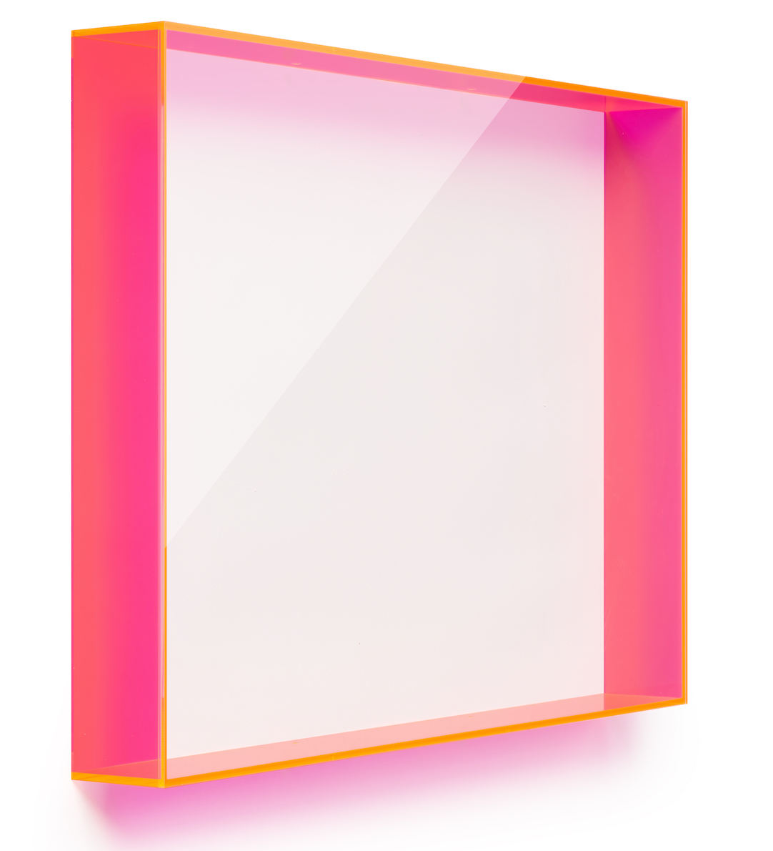
Wexel Art is offering 18x24” Shadowbox lids with colorful sides in three of their most popular acrylic colors: Seaglass, Neon Pink, and Neon Orange. This small, but striking collection will be debuting at High Point Market and featured in the highly anticipated TrendWatch program in June 2021.

The colored sides add a dramatic pop to canvas art and the 98% UV Protected acrylic preserves art against fading from sun damage. Wexel Art shadowboxes are made to fit over standard canvases, so frame your own art or head to wexelart.com and choose from their canvas art.

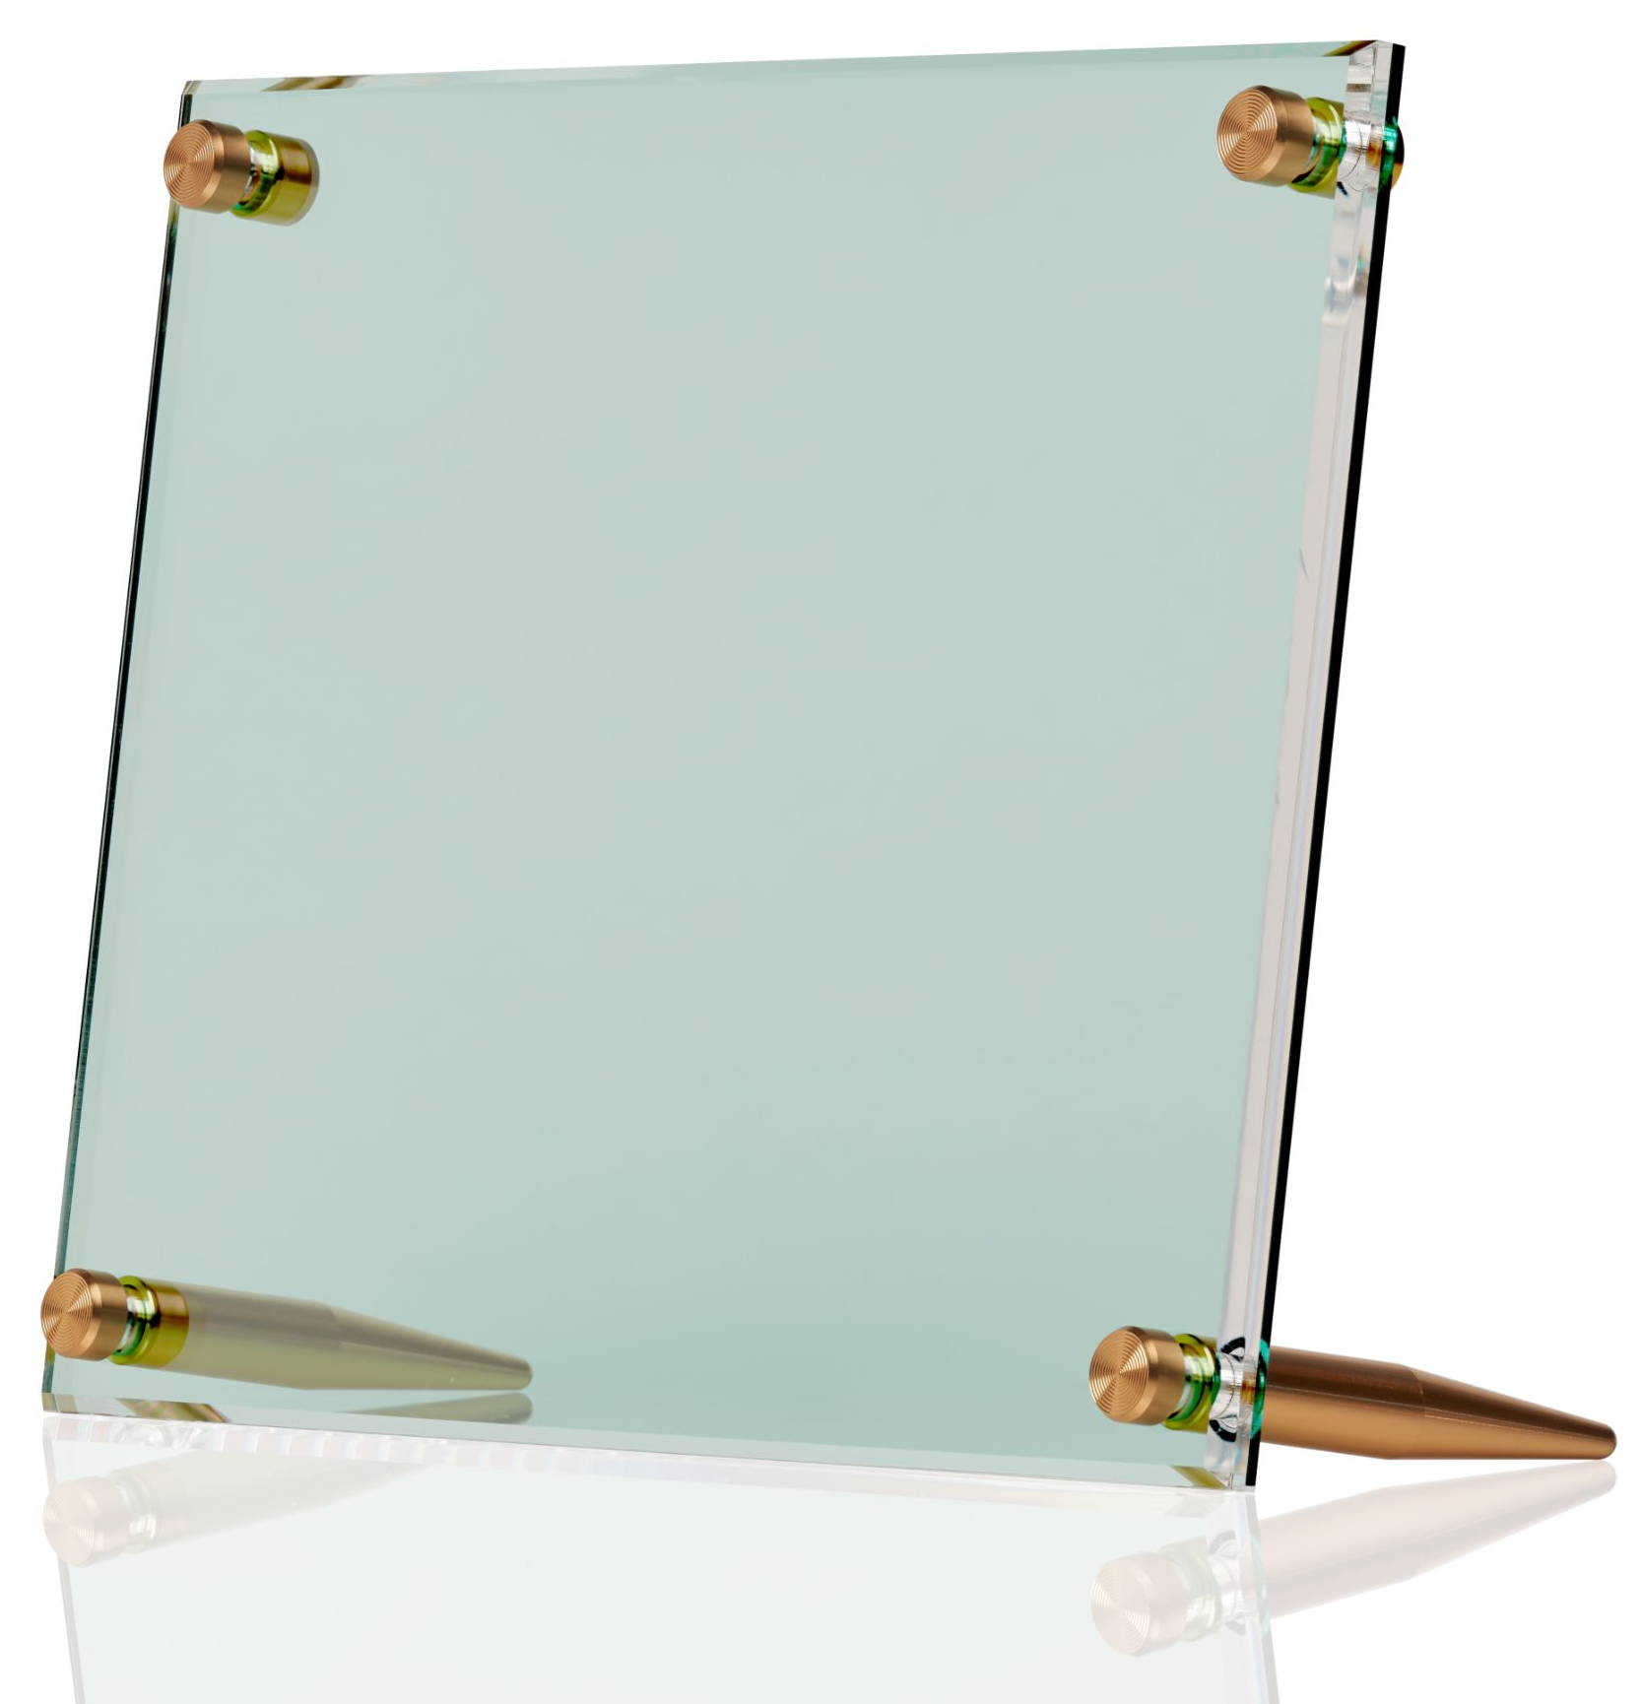
"With the home decor trend embracing the 1980's vibrant colors, our product launch will allow Designers to incorporate appealing accents, resulting in a fresh and modern view of simple beauty," said Natasha McRee, co-Founder.

Since their inception in 2017, Wexel Art’s tabletop frames have been flying off the shelves. Now available in four sizes for 4x6” to 9x12” photos, Wexel Art is expanding the tabletop collection with 19 color backing options to choose from. Mix and match your favorite acrylic color with hardware options and even engrave a message or name to make this frame a personal, one of a kind gift.

About Wexel Art
Wexel Art frames offer a contemporary way to showcase art, photos and keepsakes and the ability to change them easily and often, without the expense of traditional framing. Wexel Art was thoughtfully founded on the commitment that products should make showcasing life’s little pleasures such as photographs, kids’ paintings, and holiday cards in a clean, modern sustainable way.

