
A source for unique, bold, decorative pillows that transform spaces

FIND US

High Point Market
Suites at Market Square
G-6001S Salon Ground
Saturday, April 2nd, thru Wednesday, April 6th, 2022
Accepting Appointments

It's six short weeks away: High Point Market, in North Carolina. At Poetic Pillow, we are always looking for ways to help you bring fine art to your living spaces. Enrich yourself in the treasures that surround.

DRAMATIC FLAIR IN THE BEDROOM

This Spring, we're proudly announcing a much-expanded product line of Duvet Ensembles. Refresh yourself in the stunning artwork of Eugène Delacroix. We love his focus on color and movement and his beautifully expressive brushstrokes. Almost immediately, he was recognized as the leader of the French Romantic school. This dramatic, breathtaking duvet creates a magical space in the bedroom.

Comprised of a supremely soft duvet cover and two matching pillow cases, each duvet ensemble is made of 100% cotton sateen. Available in King or Queen sizes.

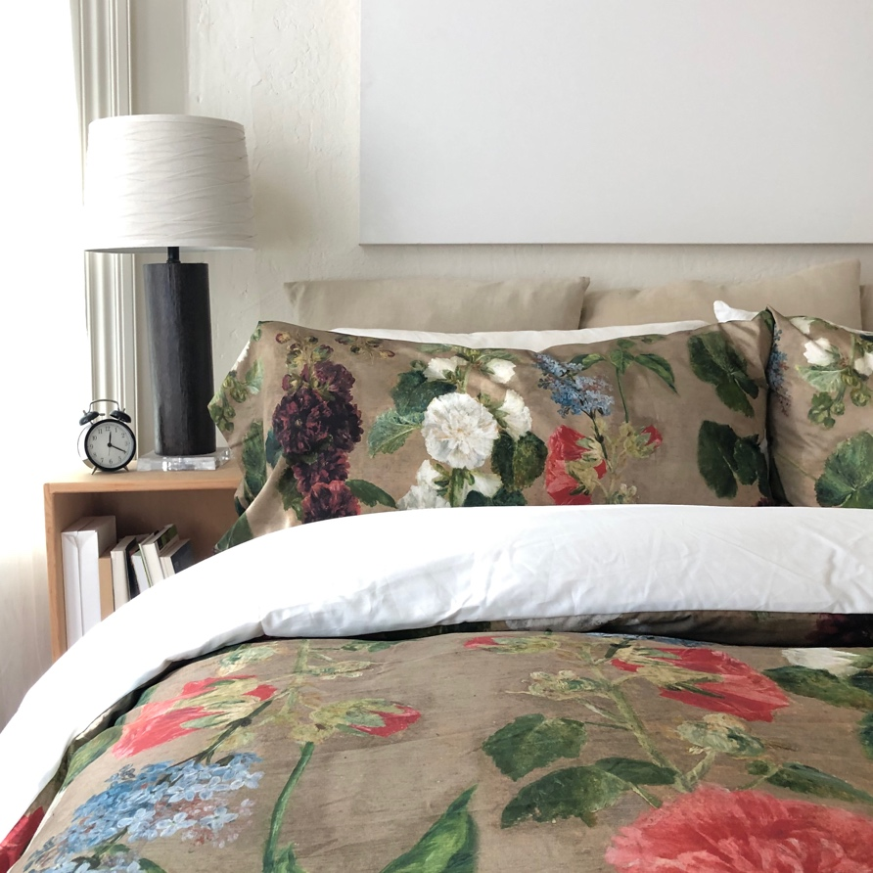

Delacroix Trellis Duvet

The right duvet really sets the tone for the entire bedroom. Consider the stunning hues of the next ensemble. Mélanie de Comoléra is best known for her works on porcelain, but we love the brilliant sense of drama in her copy of a still life by Van Huysum. All our ensembles are made one at a time in Canada and designed in California.

Once you've selected your duvet ensemble, note that we offer a velvet flanged Euro we've specially chosen as its perfect complement. Combine the ensemble with its paired velvet Euro to create your unique bedscape.

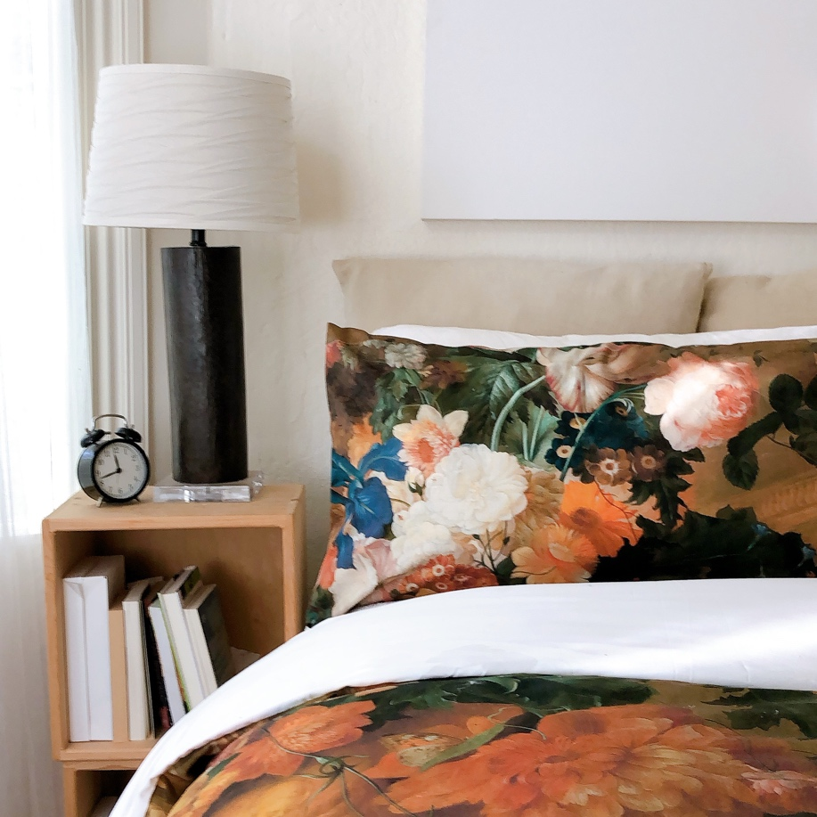

Comoléra Floral Duvet

Eelke Jelles Eelkema's stunning still lifes are masterworks of detail. We were moved immediately to introduce this Eelkema duvet. Deaf since childhood, he travelled on foot through France, Switzerland, and Italy in his late twenties, and taught visual art classes using a slate. Every petal, every nuance awakens the imagination.

Rest assured, all of our duvet ensembles are machine washable in cold, gentle cycle.

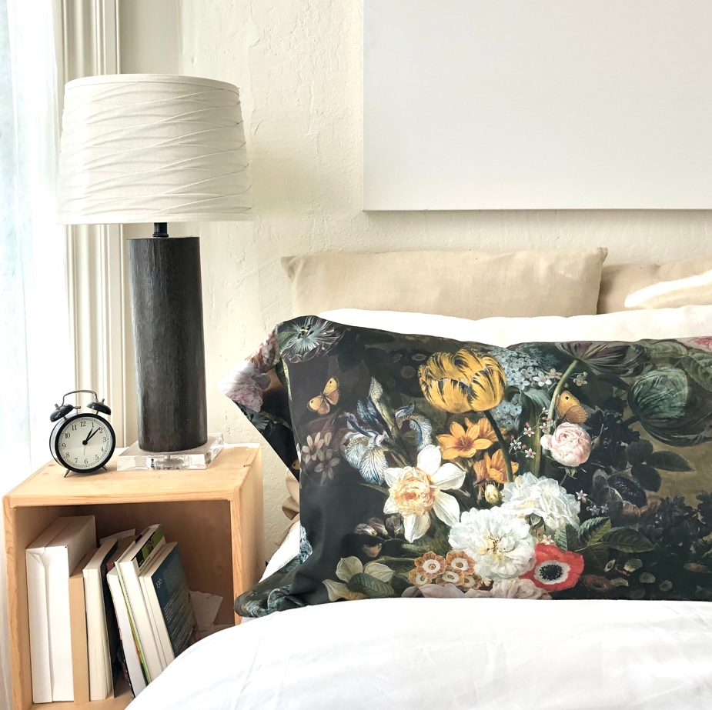

Eelkema Majestic Bouquet Duvet

We're so excited -- we've moved into a larger space on the ground floor at High Point. Won't you join us? Even more, Live Poetically.

High Point Market
Suites at Market Square
G-6001S Salon Ground
Saturday, April 2nd, thru Wednesday, April 6th, 2022
Accepting Appointments

