Pacific Coast Lighting
800-709-9004
support@pacificcoastlighting.com

Pacific Coast Lighting Offers High Point Market Attendees a
Showroom Promotion

FOR IMMEDIATE RELEASE
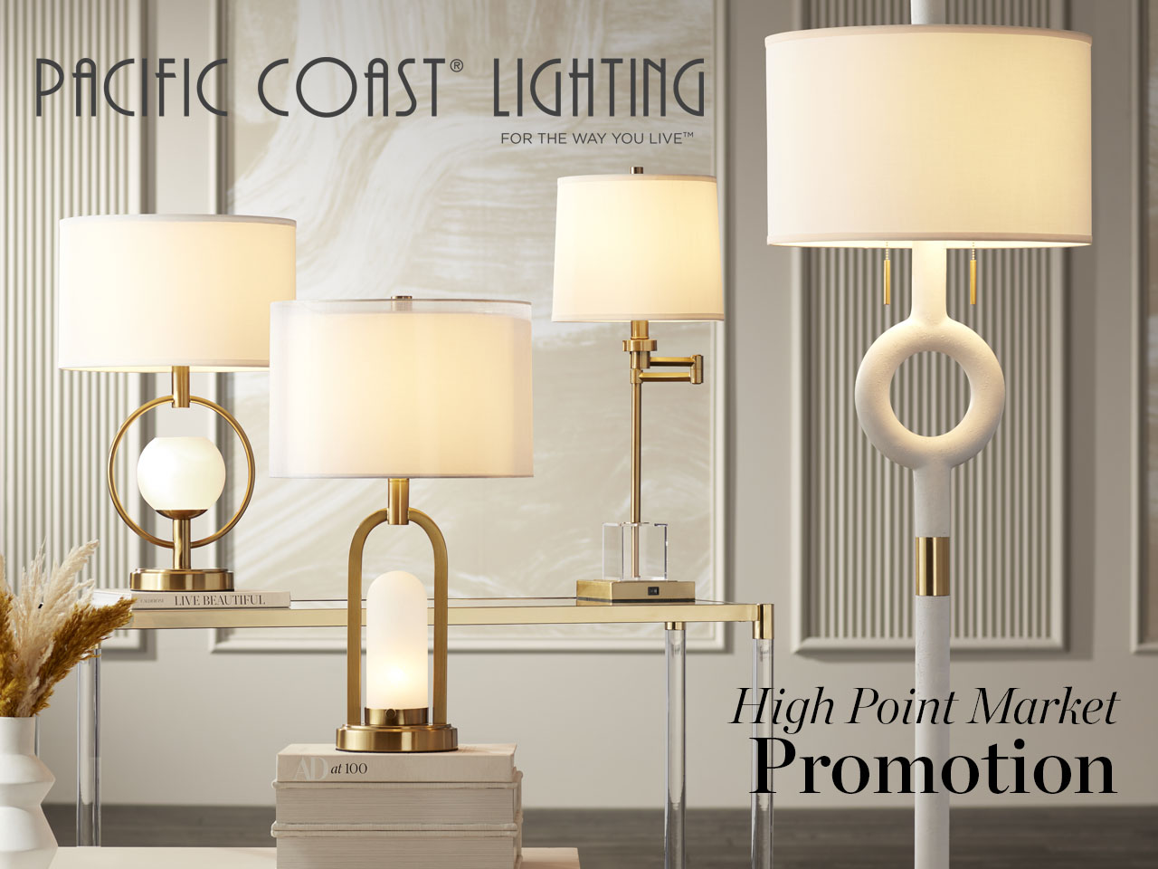

LOS ANGELES – October 10, 2022– Pacific Coast Lighting, a leading manufacturer of residential lighting that specializes in portable lighting, announced today that they are offering an exclusive market promotion for High Point Market attendees who place an order by the last day of the market.

To receive the discount outlined below, attendees must place an order in their showroom, IHFC H-203 by the last day of market, October 28th.

- 5% OFF with a $3,500 minimum order + 2 New Market Introductions
- 10% OFF with a $5,000 minimum order + 3 New Market Introductions

Terms and conditions apply. There is a one time use per customer only. Not combinable with any other discounts, promotions, or incentives. Applicable on in-line current product only. Must be for immediate shipment. Standard freight fees and policy applies. Customers should mention promo #0146. Valid October 21 – 28, 2022. Orders must be submitted by October 28th.

The High Point Market is held twice a year and is attended by retailers and home design professionals who can meet with and source designs from thousands of furniture, lighting and décor brands. The Pacific Coast Lighting showroom is located in the IHFC Building in the Hamilton wing, 2nd floor in area H-203.

For more information regarding the promotion please contact a Pacific Coast Lighting sales representative, call (800) 709-9004, or email support@pacificcoastlighting.com.

About Pacific Coast Lighting
Pacific Coast Lighting is one of the largest manufacturers of decorative lighting and accessories and is the exclusive distributor of kathy ireland® Home. With a reputation for innovative design, quality workmanship and market responsiveness, Pacific Coast Lighting sets a standard of excellence for the entire industry.

More information can be found at: www.pacificcoastlighting.com

For more information, please contact Rachel Teebken, Marketing Manager:
rsevilla@pacificcoastlighting.com

