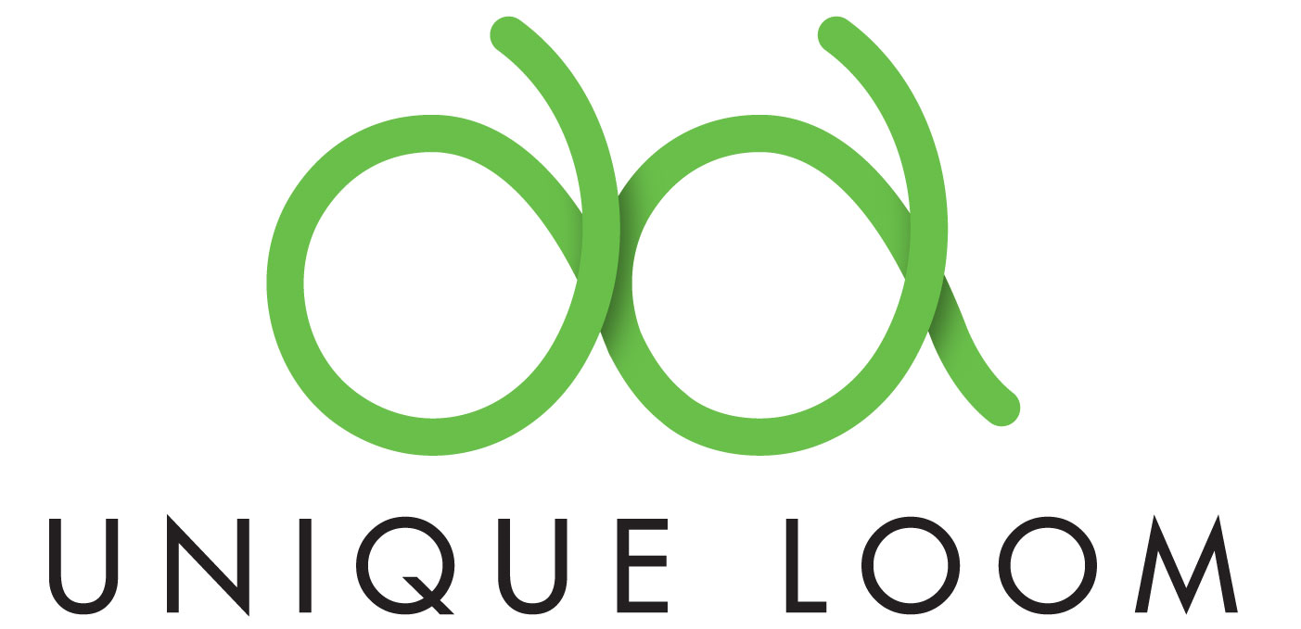

Corp Office: (800) 765-6958 | www.uniqueloom.com

Press Release Subject: Unique Loom pledges to raise $1 Million Dollars in donations for the devastating and tragic earthquakes in Turkey.

For those who hadn’t heard about the devastating and tragic earthquakes in Turkey - is one of the deadliest quakes in this century. Striking Monday morning, February 06, 2023 around 4 a.m, the 7.8 magnitude quake struck 23 kilometers (14.2 miles) east of Nurdagi, in Turkey’s Gaziantep province, at a depth of 24.1 kilometers (14.9 miles) and has had 100 aftershocks since the initial earthquake.

International Rug Manufacturer Unique Loom, shared how this tragedy in Gaziantep is evolving and how they are looking for donations to support their ongoing efforts in the coming weeks and months ahead.

Unique Loom commented, “It is with a heavy heart that we reflect on the devastating and tragic earthquakes that recently struck our beloved and familiar city of Gaziantep. Many are still isolated due to frigid temperatures while blocked roads are preventing rescue teams from reaching the affected areas and those in need. The impact of this disaster has been nothing less than catastrophic, with widespread destruction that has left many without homes and necessities.”

“Our thoughts and prayers remain with the people of Gaziantep and their affected families.This tragedy serves as a stark reminder of the fragility of life, and the importance of coming together to support one another - so please feel free to share our donation efforts with your friends and family. Let us be a shining example of compassion, generosity, and humanity.”

Unique Loom further shared, “Gaziantep and its resilient people have played an immense role in the growth of our company in the last decade. While our headquarters are in South Carolina, a large portion of operations are in Gaziantep, and our unique position on the ground comes with a major responsibility.”

Currently, two of Unique Loom’s production facilities in Gaziantep have been designated as structurally sound, and they are operating them as shelters for those in need. Unique Loom has also set up two pop-up kitchens to provide food for those sheltering. Adding that in situations like this, nothing is enough and we hope to do much more for those affected by this unprecedented disaster.

Using our company's nonprofit organization called Maman Foundation (in honor of Unique Loom’s mother who passed away 11 years ago and whose life's work was philanthropy), their company has established a GoFundMe campaign, to support the survivors and our beloved Uniqueans who have been displaced from their homes.

Pledging to match any and all donations (dollar-for-dollar) up to our goal of $1,000,000 USD - Unique Loom is dedicated to providing the necessities needed for this catastrophic earthquake’s relief.

Unique Loom shared, “Your contribution, no matter how small, will go a long way in helping the survivors and our employees get back on their feet. Your donations will provide food, shelter, warmth, clean water, medical care, and other essentials for rebuilding their lives. Please help if you can.”

To contribute, please visit: http://gofundme.com/Unique-Loom-Turkey



