FOR IMMEDIATE RELEASE
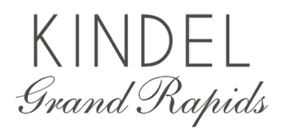

Kindel Grand Rapids X Jacob Lukas Design

March 30, 2023 Grand Rapids, Michigan— Chicago based, and Nationally known firm Jacob Lukas Design, has partnered with Kindel Grand Rapids to created an instant classic with their Lyric Chest for Kindel Furniture. “Working with Michigan based Kindel Furniture is a dream realized.” Says Kurt Jacob Miller of Jacob Lukas Design. “Our love affair with this esteemed brand, goes back to college days In Grand Rapids and Summers spent at the Grand Hotel,” adds Lukas Mack. Together, the duo has added a fresh perspective to a versatile classic.
Featuring clean lines and soft gold “dentil” detail, this beauty is equally at home in Palm Beach or Park Avenue. Hand cast solid brass hardware is specific to this design. Available in a multitude of custom configurations and colors, the Lyric Chest fits any interior and represents the highest level of quality in American made furniture!
The Lyric Chest for Kindel, is available in a variety of custom configurations and a rainbow of colors. “It is a true honor to work with this 120 year old American manufacturer, notes Kurt.”
About Kindel:
Kindel Grand Rapids is an American luxury furniture brand that includes Kindel, Karges, and Councill. Based in Grand Rapids, Michigan, these brands are committed to bench-made methods and hand craftsmanship. Today, they are uniquely positioned as the preeminent source for luxury furniture made in the United States.

Business contact:
Kindel Grand Rapids
616-243-3676

Rob Burch, CEO
rburch@kindelfurniture.com
616-550-4213

Gretchen Keith, Vice President of Marketing and Brand Management
gkeith@kindelfurniture.com
812-550-3043

