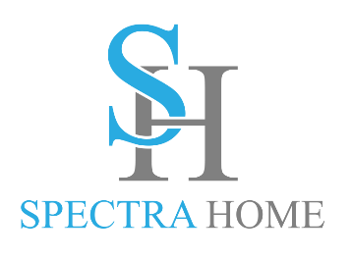

Contact: Cathy Lloyd
The Media Matters, Inc.
336.707.4462
cathy@tmm.agency
Spectra Home Adds New Fashion Colors
to the Spectra Leather Collection
High Point, NC, October 14, 2023 – Spectra Home, known in the industry for their superbly tailored upholstery, is expanding their Spectra Leather selections to include six new on-trend colors of luxurious top-grain aniline-dyed leather. Market attendees can see the entire leather gallery in the Spectra Home High Point showroom, 200 N Hamilton #213, October 14-18.
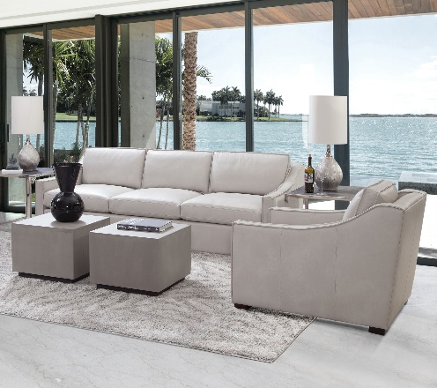
“Leather remains a popular choice for upholstery because it is durable, easy to clean and offers the ultimate sustainability story because it is made to last,” stated Jim Telleysh, president of Spectra Home. “We use our own in-house tannery at our factory to ensure the highest quality of aniline dyed leather is used on our furniture. It is a quality investment that is designed to last for many years which is a great selling point for consumers.”

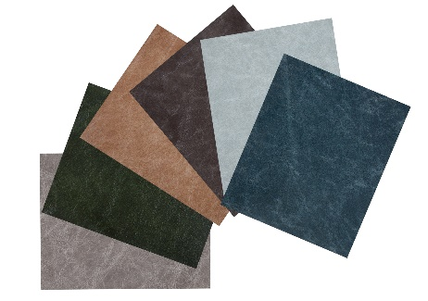
In addition to the top-selling leather favorites of Brompton Brown, Cavalier Navy, Cortina Black, and Parrot Grey, Spectra Home has added Crystal Charcoal (light gray), Crystal Forest (hunter green), Crystal Sand (tan), Fargo Smoke (dark gray), Crystal Baby Blue (sky blue), and Crystal Bayou (teal) to complete its fashion statement. The full leather traditional and transitional style sofas, chairs and ottomans have eight-way hand-tied construction, hardwood frames, and down-filled cushions for seats and backs. Nail head trim, finely executed button tufting, contrast welting and channel stitching are just a few of the added finishing details offered in the Spectra Leather program. Plus, many of Spectra Home's fabric sofas and chairs can be special ordered in leather, further increasing the variety of styles and silhouettes from which to choose.

# # #

About Spectra Home: Spectra Home designs and manufactures luxuriously comfortable, fashion-forward, and exquisitely tailored upholstered furniture using time-honored construction techniques including hand-cut and -sewn fabrics and leathers. The company is based and warehouses product in High Point, NC. For more information, visit spectrahomefurniture.com, Facebook, Instagram, Pinterest.

