FOR IMMEDIATE RELEASE
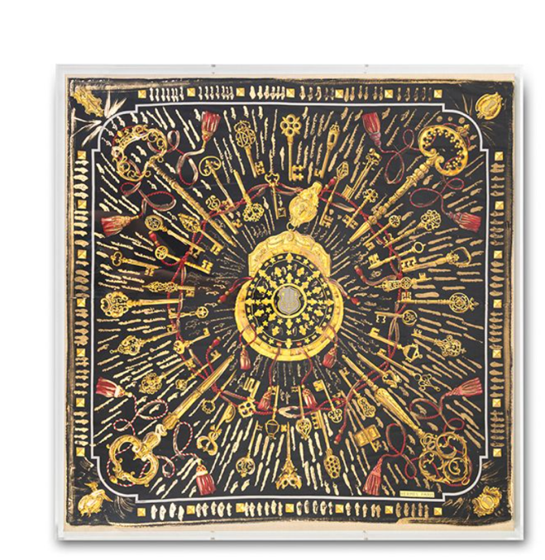
Contact:
Wexel Art: info@wexelart.com
Aviva Stanoff: press@avivastanoff.com
Wexel Art and Aviva Stanoff Join Forces to Elevate Home Decor with Unique Collaboration
[Austin, Texas , April 3, 2024] – Wexel Art, the pioneering innovator in acrylic frames, announces a dynamic collaboration with Aviva Stanoff, the renowned textile artist and designer. This partnership marks a significant milestone as two leading brands in the home decor industry unite to create a fusion of artistry and functionality.
Known for their signature shadowbox frames, Wexel Art has long been recognized for its commitment to elevating the presentation of art in homes and spaces around the world. Aviva Stanoff's distinctive textile art, inspired by nature and infused with luxurious textures and colors, has captivated audiences globally. Now, the collaboration between these two creative companies promises to deliver a unique and enchanting experience for art enthusiasts and interior decorators alike.
At the heart of this collaboration lies the contagious energy of Aviva Stanoff transforming vintage luxury scarves with her artistic flair & deep knowledge of textile art and partnering with Wexel Art to frame and display them in their high quality UV grade acrylic shadowbox frames. This marriage of artistic visions and craftsmanship results in a stunning display that will debut at InterHall, during High Point Market, April 11, 2024. See how these two brands combine their energies, offering a fresh perspective on home decor.
Aviva Stanoff expressed her excitement about the collaboration, stating, "Partnering with Wexel Art allows me to explore new dimensions in presenting my textile art. The 3D shadowbox frames are a perfect complement to further elevate her new favorite “canvases”, scarves hand-painted with her signature gold detail.
Natasha McRee, CEO of Wexel Art, shared her enthusiasm for the collaboration, saying, "Joining forces with Aviva Stanoff’s exquisite textile art to life in our signature shadowbox frames is a natural collaboration where our fusion of creativity & innovation resonates with our discerning clientele who appreciate craftsmanship and design excellence."
The collaboration between Wexel Art and Aviva Stanoff exemplifies a shared commitment of creating high quality products that are made from repurposed materials like vintage Hermes scarves to offer consumers a fresh perspective on how art can transform not only your living spaces, but also elevate your mood.
Commissions will be welcome! For more information about the collaboration and to explore the collection, please visit www.wexelart.com and www.avivastanoff.com .
About Wexel Art: Wexel Art is a leading provider of acrylic frames and display solutions that enhance the presentation of art and keepsakes. With a focus on innovation and design, Wexel Art offers a wide range of products that cater to both residential and commercial spaces.
About Aviva Stanoff: Aviva Stanoff is a celebrated award-winning textile artist and product designer known for her exquisite creations inspired by nature and luxury. With a dedication to craftsmanship and attention to detail, Aviva Stanoff's designs have garnered acclaim from clients and critics worldwide.
[Note to Editors: High-resolution images and additional information are available upon request. For media inquiries, please contact:info@wexelart.com and press@avivastanoff.com
--

