My Favorite Finds at 220 Elm – High Point Market
APRIL 18, 2015 BY: JEANNE1 COMMENT

220 Elm at High Point Market
I am currently at High Point Market attending the world’s largest furniture market, which is held semi-annually in High Point, North Carolina. Each spring and fall, High Point Market brings 85,000 buyers, exhibitors, and designers to the area to see the latest in furniture, home accessories, and interior design trends. Collectively, High Point Market consists of 11.5 million ft2 of show space, but in this post I will take you through 220 Elm, one of the buildings in the main downtown High Point and houses a diverse mix of clean and sophisticated contemporary design.
The past two days I’ve spent going through the showrooms in 220 Elm and have selected several finds that caught my eye to share and perhaps to entice you to come and see what 220 Elm is all about. While this is just a quick peek at what the building has to offer, by no means is it limited to what I’ve shown here.

My Favorite Picks at 220 Elm
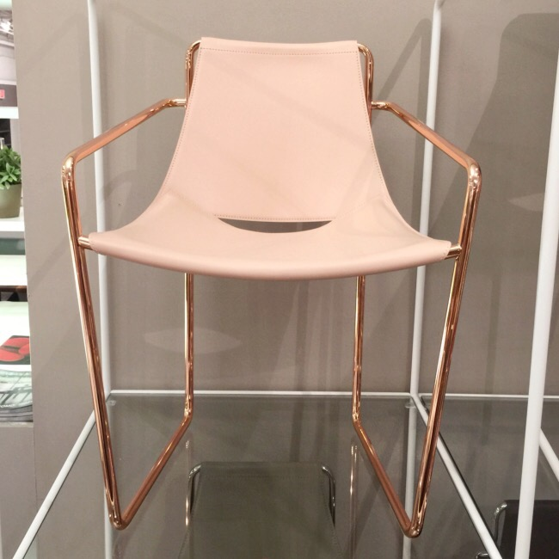
Apelle Armchair from MIDJ at Leif Petersen
A sleek and sexy “pink gold” (aka copper) frame chair mixed with leather from MIDJ atLeif Petersen. It’s amazing what a little nuance can do for a piece of furniture.
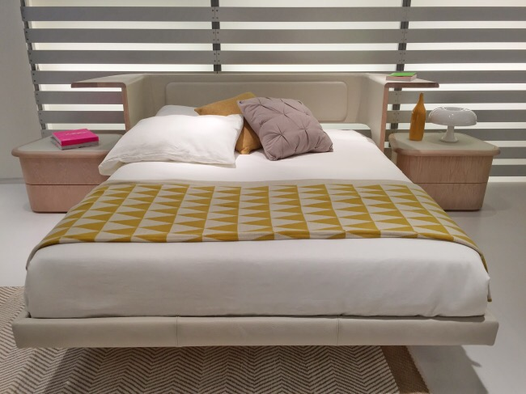
Huppe
Huppe‘s uniquely designed bed allows you to keep all your important items within arm’s reach when in bed.
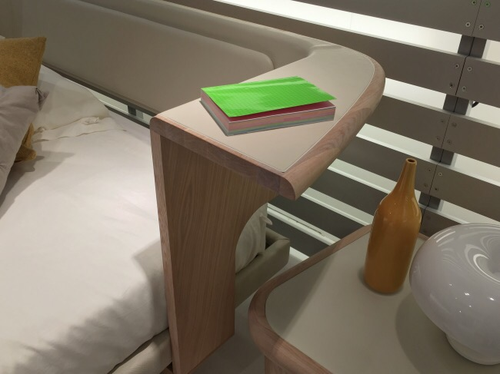
Huppe
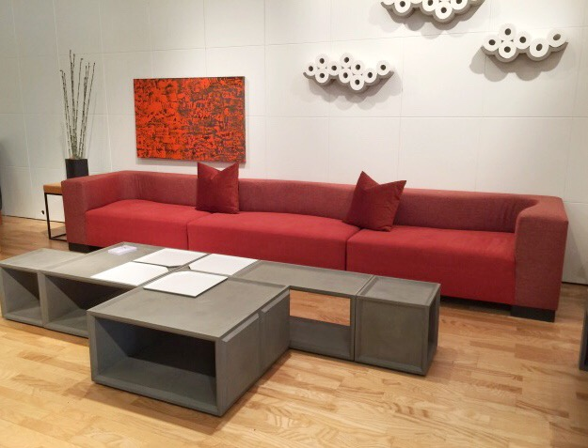
Lyon Béton
Lyon Béton‘s furniture line made of cast concrete is a sure bet for both indoor or outdoor living. Modular pieces can be configured in an endless amount of ways (think Legos, but only bigger….and better). They can be configured horizontally to create a cocktail table or vertically to create shelving. Ingenious! They also have full sized dining tables, cafe chairs…and even an artful way to store your toilet paper in the bathroom with toiletpaper “clouds” (see the wall on the photo above.) This is one line that we’ll be sure to see much more of.
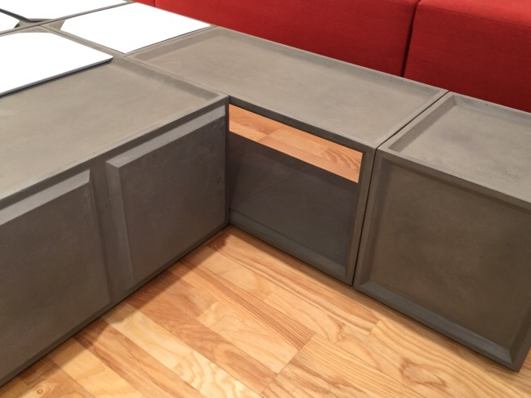
Lyon Beton
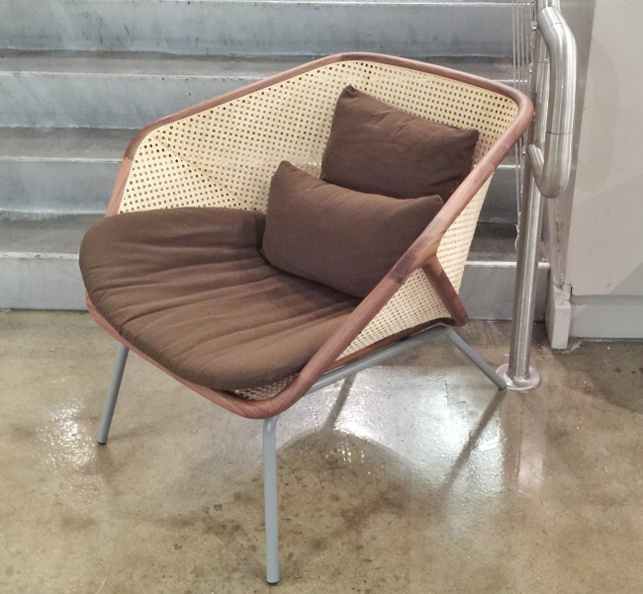
Miniforms at Leif Petersen
This chair from Miniforms is not only extremely comfortable, but it is equally as stylish. It is an unusual mix of wood, caning, and metal that is both warm and inviting.
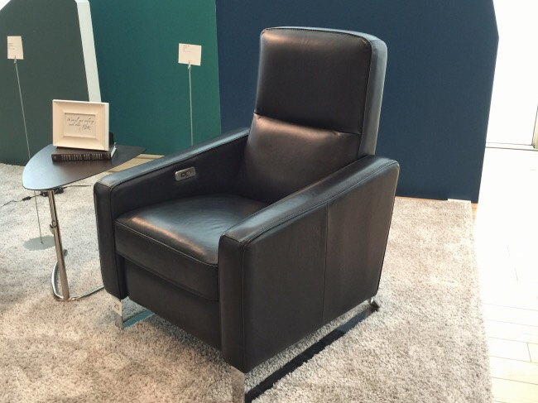
Motion Recliner from Palliser
Move over bulky and awkward recliner. Palliser makes the sexiest recliner around. A slender profile and stainless steel legs will keep marriages intact, as husband and wife will no longer be arguing about what to put in the family room. Wife gets to incorporate beautiful design and the husband gets to sit in comfort with legs elevated, where he’ll sit for hour,s as with the built in USB outlet in the armrest, there is no longer a need to get up to charge his device.
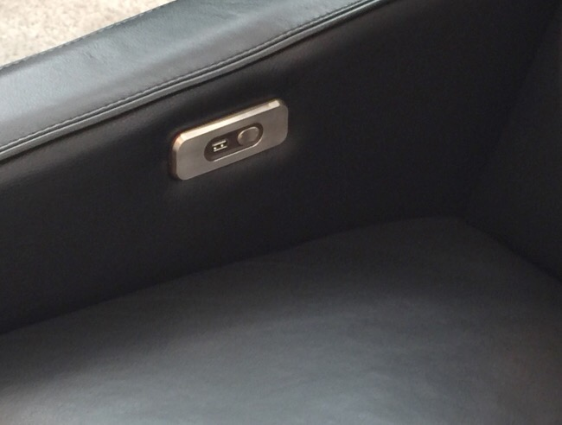
USB and power feature , Palliser
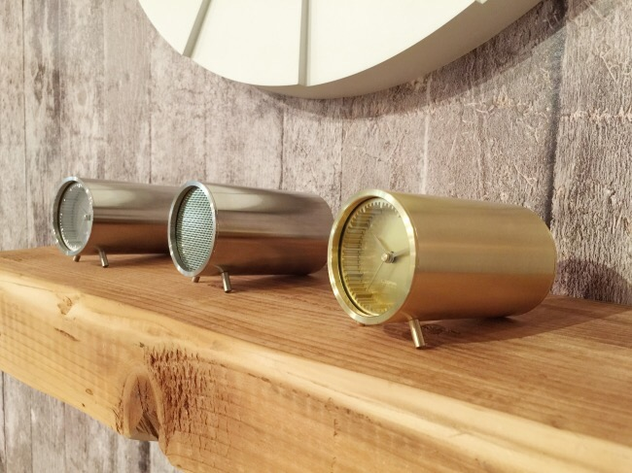
The Tube Series from Piet Hein Eeek at Leif Petersen
I saw a preview of the Tube Series before market, and this is one thing I wanted to see in person. Clocks and USB speakers designed by Dutch designer Piet Hein Eeek in a variety of metal finishes (not shown here is copper, which is equally as captivating) can be incorporated into rooms of varying design styles. They are even more beautiful in person!
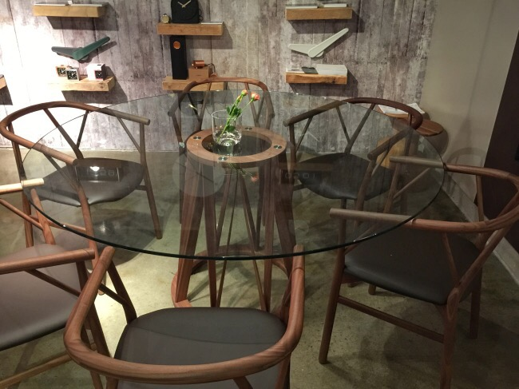
Miniforms at Leif Petersen
I love a glass table top when there’s something interesting to show below. The base on which the table top sits is just that- an interesting shape and the accompanying chairs are made of the same unfinished wood and give a modern, artisanal feel to the set.
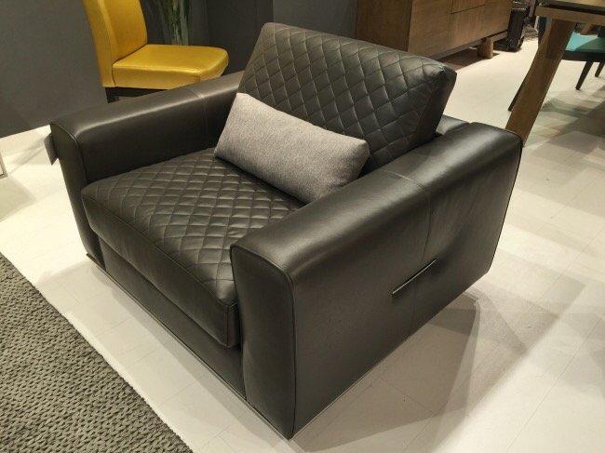
Bugatti Design
A masculine silhouette with feminine quilting is what drew my attention to this chair from Bugatti. It is also just as comfortable as it looks.
Innovation had an endless supply of convertible sofas, but I thought I’d share this video to demonstrate how easy it is to go from sofa to bed in just a manner of seconds.
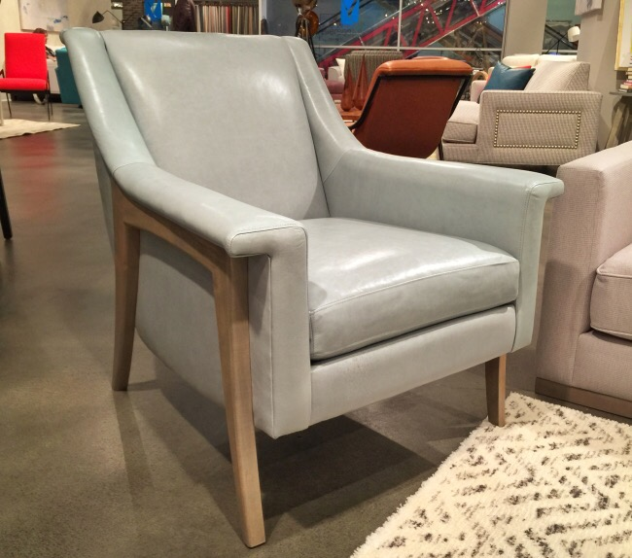
Younger Furniture
Younger Furniture showed this exposed wood frame chair in the palest of pale aqua leather – a color that I have been seeing all throughout market. In addition to the frosty shade of aqua, I also love the reference to midcentury design.
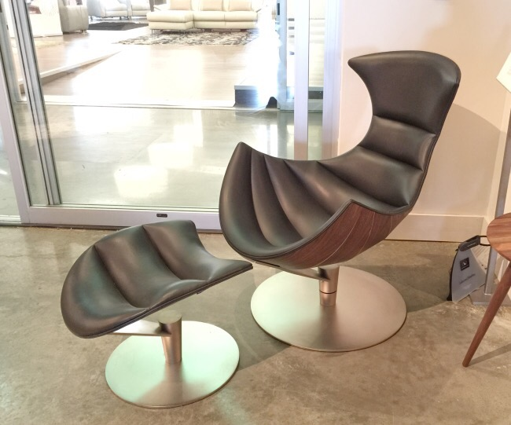
Fjords
Norwegian manufacturer Fjords showcased this chair and ottoman which is an homage to Arne Jacobsen’s iconic egg chair. I especially love the horizontal channel tufting which contributes to both the form and function of the chair.
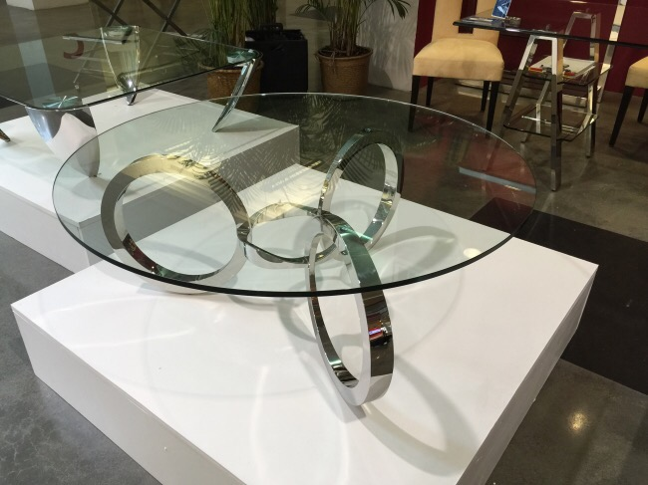
DIA – Design Institute of America
The DIA (Design Institute of America) has a large showroom off site, but for this market they set up a satellite show space on the 3rd floor of 220 Elm. Clear glass tables highlighted the sculptural stainless steel forms underneath, and this was one of my favorites.
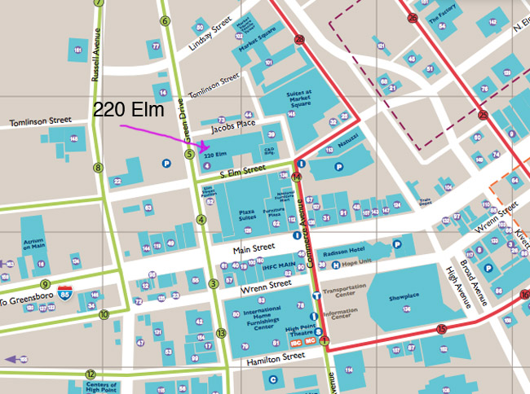
If you are at market, stop by 220 Elm and have a look at everything the building has to offer in person. For your convenience, I’ve marked off where 220 Elm is located on the map above. If taking the market shuttle, you would take the #5 shuttle on the green route, and #14 on the red route. If you are unable to attend market, I will have much more to report on High Point Market and will also have more coverage of 220 Elm, so stay tuned!

