Flexsteel Turns a Page

From beach chairs to park benches, the best design read this year may just be a corporate website.

The best summer reads—the ones that top each year's bestseller lists—usually combine a good story with a little romance. Not surprising then that the execs at Flexsteel Industries are betting they have a potential hit on their hands with Flexsteel.com, an entirely revamped brand website designed to make shopping for a sofa, well, a day at the beach.

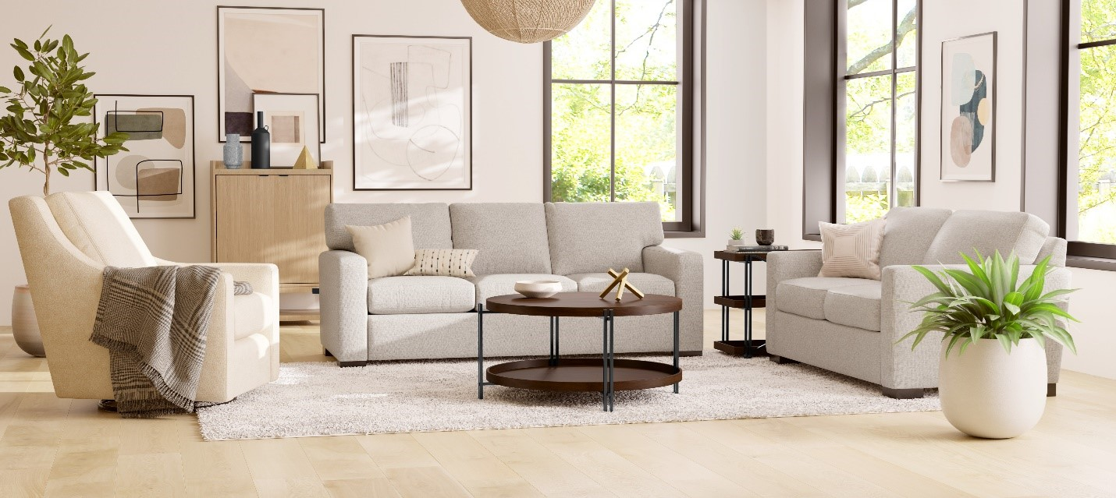

While we consumers can shop for just about anything, just about anywhere these days, the furniture category has long presented something of a conundrum. For one thing, a sofa is a big-ticket item, not easily returned, and something we don't typically shop for very often, especially since even a poorly constructed sofa will likely last a few years. That leaves the decorating challenged without a lot of experience in the matter, and with a lot riding on making the right decision. Choose well and prepare to sit back in satisfaction and comfort, enjoying the compliments of family and friends. Choose incorrectly, and you're saddled with a costly decorating mistake that will be a source of unhappiness and discomfort for quite some time to come.

A New Decorating Ally
Flexsteel is a leading furniture manufacturer determined to take the guesswork out of the decorating game—stacking the deck for consumers by loading their new website with a variety of high-tech tools designed to assist in what many see as a time-consuming, and sometimes altogether frustrating, shopping process.
At first glance, the company would seem an unlikely contender for position of decorating ally in the digital age. Based not in Silicon Valley, but in Dubuque, Iowa, the maker was launched more than a century ago, when searching for just the right sofa anywhere other than inside a brick-and-mortar store—much less while parked on a beach blanket—would have sounded like so much science fiction. Yet, the maker's journey from traditional furniture company to its recently stated goal of becoming a true omnichannel presence in the home furnishings marketplace, is a story that appears destined to become a case study in the how-to-succeed-in-business genre.
It begins with a legacy of quality products, and a unique innovation that dates back to the 1920s, when Flexsteel introduced its proprietary blue steel spring™, a patented ribbon of steel that revolutionized upholstered furniture manufacturing in those days and has made for a clearly defined brand story in all the years since. From the start, the manufacturer focused on telling its story to retailers across the country, for the most part relying on those dealers to convey its benefits—the spring never actually wears out or requires adjusting over time—to their stores' customers, the furniture buying public. This marketing approach, which focused nearly all selling efforts on gaining coveted space for Flexsteel's products on retail floors, worked fine for decades. Indeed, over time, the company would grow to become an industry leader, going public in the 1960s, and eventually expanding their product offering to encompass not only upholstered goods, but major collections for every room in the home.
"Then came the big shift in how we, as consumers, shop for everything," says Sharad Mathur, vice president of marketing at Flexsteel. "While nothing changed in terms of our capability to design and manufacture fashionable, quality products that will last, in little more than a decade, we moved from the industrial age to the digital. For consumers, new tools continue to appear at an ever-quickening pace, from the first time we used a Google Map to find our way, to the introduction of the iPhone, to our first Uber rides, and all the mobile apps we've learned to use—and come to depend on—along the way. People now habitually start their shopping process online, no matter the product, and the pandemic has only accelerated this trend. Prior to a purchase, they expect to find all the information they require to make their buying decision on your website, on your mobile friendly app, on a screen of one sort or another, wherever they happen to be."
Beginning a New Chapter
The challenge for a company like Flexsteel, born and bred in the industrial age, was how to evolve its very traditional marketing approach to remain relevant in this new reality. Thus, the launch of Flexsteel.com, which supplants a site that was by all accounts dated and quite corporate in appearance (read that boring). The new version is cleaner, brighter, bolder, and from a visual standpoint, much more in line with the look of a major specialty retailer.
Though aimed squarely at a consumer audience, the site remains strictly B2B in support of the retailers that sell Flexsteel's products. "We recognize that the success of our business here at Flexsteel is directly tied to the success of our retail partners," says Jerry Dittmer, chief executive officer, "so our goal was to develop a seamless experience linking our digital platform and our brick-and-mortar dealers to better meet the needs of today's consumers."
"Our website is about providing inspiration, information and communicating our brand story to shoppers," Mathur emphasizes. "The robust digital tools we now provide are designed to lead site visitors to retail stores to complete their purchase, and to assist those stores in positioning and promoting our brand to their customers."
Get me Rewrite!
One of the new tools that will no doubt curl everyone's toes in the sand (or anywhere else for that matter), is digital draping—enabling site visitors to visualize and customize furniture styles and fabrics with a click. Forget the heavy rings hung with small fabric samples that have long forced shoppers to flip back and forth from one small swatch to another, trying to imagine what a sofa might look like wearing each. Just choose a customizable silhouette from Flexsteel's expansive selection of sofas, chairs, and sectionals, and then personalize the look with your choice of more than 250 standard fabrics from the company's popular South Haven collection. Tap on a fabric and the tool immediately "drapes" your piece, fully covered in the chosen color and pattern. No guesswork necessary.
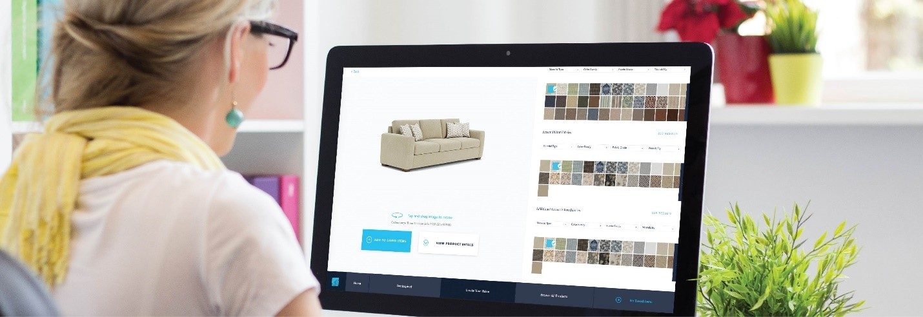
Users can then rotate the resulting image 360 degrees to view their selection from all angles, zooming in and out to study it closer. Say that green floral sofa with plaid pillows is not quite what you imagined, just drape it with another fabric, changing the base cloth and/or the accent material as many times as necessary to create a look you love.
Among the choices included in the South Haven collection's simplified pricing program are performance fabrics with stain resistance—we're talking to you parents of small children and pets—sustainable options and even fabrics with UV protection. Still determined to go old-school and insist on actually touching and feeling your chosen material in person? Tap again to request a swatch be sent for your hands-on review.
When a Flexsteel.com visitor hits upon an ideal fabric and frame combination, they can add the image they have created to their favorites, email it to themselves, and/or share with friends, family members via social channels. Or simply print the image out to show a salesperson on the floor of their favorite furniture store exactly what it is they are after. Suddenly, buying furniture and decorating a space—long considered an overwhelming task by many—is something akin to a video game. Winning is easy. Convenient. Confidence boosting. Fun!
Wait, There's More
As whiz-bang as all this sounds, Mathur is quick to note that the company's digital journey is just beginning. Even so, there are already more tools available here to help consumers create beautiful spaces than the company has ever previously provided. Along with the aforementioned draping tool, the newly interactive website is loaded with bolder, more inviting images, improved navigation, and…a room planner.
The room planning tool enables site visitors to move beyond customizing a piece of furniture, to actually placing the furniture in a space. "You input your room's dimensions, along with architectural elements like windows, doors and fireplaces, and the room planner makes it simple to choose from any of our products and design your entire room to scale," he explains.
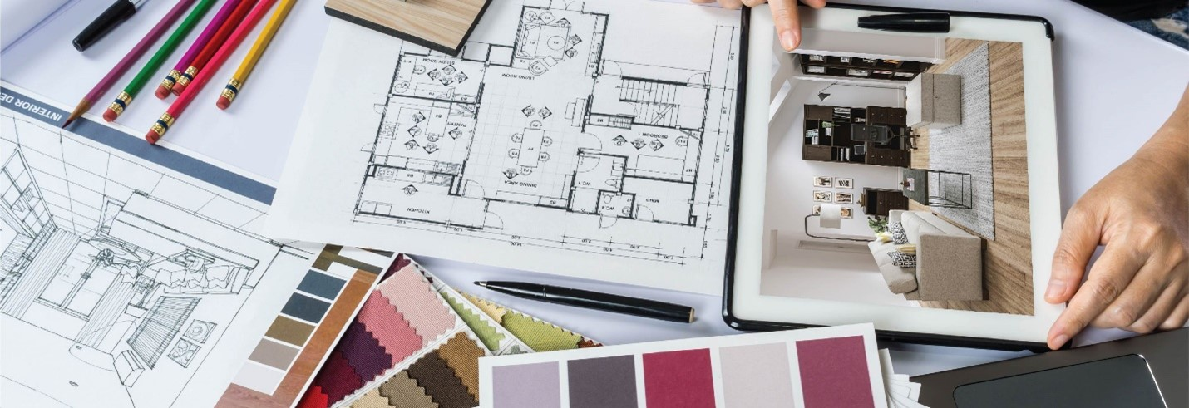
Set aside the razzle dazzle designed to engage consumers and invite play, and the company's mission becomes quite clear. These new digital tools virtually nullify the possibility of making a decorating mistake, while exponentially increasing the customer's peace of mind about prospective purchases. There is yet more to come. Virtual reality—the kind that enables users to actually move around inside a space they have created—figures prominently in the company's plans over the coming months.
The Plot Thickens
Any good summer read includes page after page designed to engross and move a story forward, and the concept holds just as true here. Anyone who may have encountered the company's previous website, will immediately grasp that its sequel is far more expansive and compelling. Indeed, the company's writing team has been hard at work developing fresh, informative, best-in-class content that is conversational in tone, relatable and smart. In fact, the new site arrives with an ever-growing library of inspirational blogs packed with design ideas and advice, all aimed at helping people make more informed decisions.
Read through the vastly improved copy and the underlying message of the brand's legacy—the quality construction story at its very heart—continues to beat unchanged. Additionally, all of the new content is seamlessly syndicated to the websites of Flexsteel retailers across the country, which ensures that no matter where consumers encounter the brand, the information they find will be accurate, up-to-the-minute, and most important, consistent.
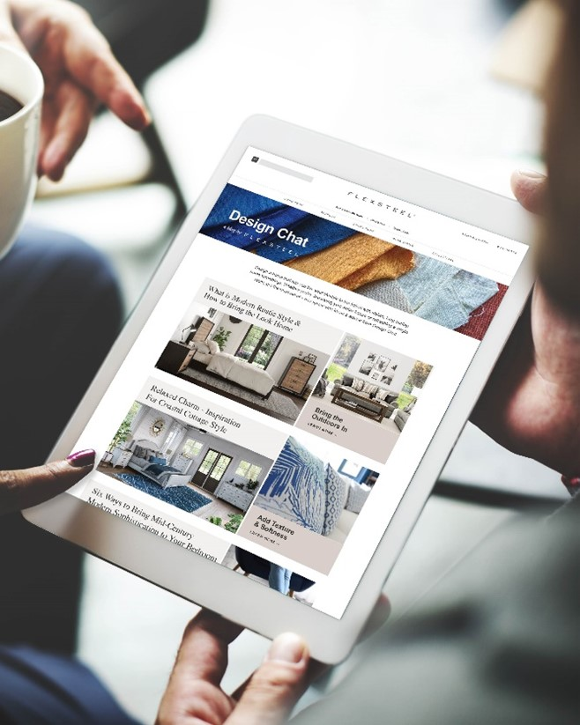

Although Flexsteel.com is the most outward expression of Flexsteel's transformation into an omnichannel presence, Mathur reports that it is actually only one chapter in the company's unfolding marketing plan. Others delve into brand basics like refreshed store signage and point-of-purchase materials, an updated, easy-to-use in-store kiosk, and, of course, a mobile app. As is appropriate in the current environment, there is also plenty of audience engagement already at work through improved social outreach via Facebook, Instagram, and other channels.
"Our over-arching goal now is to create conversations with consumers, sharing what's new and how we're trying to position ourselves as a design leader," Mathur says. "We want to know who they are, what they think about us, and what we can do better. Rather than talk at people, we want to really communicate. And being truly omnichannel means that we need to be ready to talk whenever and wherever they want to have the conversation with us."
In other words, the dialog in this story will be ongoing. "We're on a journey, and it's one that never actually ends," the executive says. "Flexsteel accomplished wonderful things for more than one hundred years, all of which were relevant for a company in the industrial age. Now, the marketplace has evolved, and we are transforming along with it. The end of our story is a long way from being written, but for us, the time has come to turn the next page."
# # #

