|  |  |
| --- | --- |
|  | FOR IMMEDIATE RELEASE  **FOR MORE INFORMATION AND IMAGES** |

|  |  |  |
| --- | --- | --- |
|  | Edward M. Tashjian  Company Spokesperson  Tashjian Marketing  (828) 320-0117  ed.tashjian@gmail.com | Laura White  Vice President of Marketing & Creative  Vanguard Furniture  828-328-5601  lwhite@vanguardfurniture.com |

**New Traditional**

*Where time periods collide blending past and future into a perfect present*

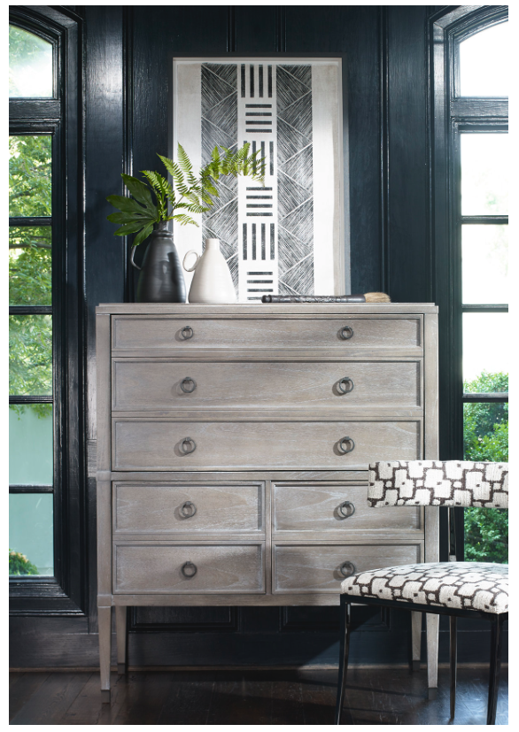

**Hickory, NC** (October 2, 2018) — Compendium is Vanguard’s oldest active collection and each season the talented designer team breathes new life into it. It’s called Compendium because it is a systematic compilation that integrates the best neoclassical designs with contemporary scale and materials.

What’s old is new again in our sophisticated New Traditional introductions. Classic forms are reinvented and reimagined with a fresh mix of finishes that are timeless not trendy. Inspired by art, architecture, wallpaper and pattern, it encompasses a mix of styles stretching across centuries. Perfect for the purveyor of fine things, New Traditional inspires new confidence in everything classic.

The reason variations of 18th Century designs have remained popular for 400 years is because they are timeless forms that are still relevant and provide the bones of continuity that span the crazes and vagaries of evolving preferences. Confident and sophisticated opinion leaders have always had varied tastes. This is reflected in the way we dress, live and eat. Why not in our furnishings? Our target consumer is well traveled, though they seldom visit the same place twice. Their art, collections and memorabilia represent a diverse and distinctive kaleidoscope of preferences and experiences that echo their unique personality. So, should their furniture.

Andy Bray, Vanguard’s President, opined, “We call it curated eclecticism. We study pieces within our line and from history to see what is working and what is not. A good form can have a very long life that can be expressed in a variety of finishes, fabrics and hardware which can be tailored to an individual’s tastes. Good design works with good design no matter what time period it is from.”

Indeed, the new offering represents tradition with a twist. Timeless forms anchor contemporary finishes, textures, shapes, and scale to make them new. Exotic materials like bees’ wings veneers (so called because of a light shimmer) combine with new finishes to create something fresh and at the same time classic. Linear forms and tapered legs combine with chevron parquet to create a statement that is modern and at the same time redolent of time-honored neoclassic design.

**About Vanguard Furniture**

Vanguard Furniture is a manufacturer and marketer of case goods and upholstery. It is a family held company, employing 600 associates and operates out of six manufacturing buildings in Hickory, North Carolina, and a 40,000-square foot showroom in High Point, NC and Hillsville, Virginia. Its mission is to lead home furnishings in style, value and service with a vision to enrich lives through custom-crafted furniture. Vanguard is a founding member of the Sustainable Furniture Council and its green initiatives include recycling 95% of all post manufacturing waste; recycling paper, fabric scraps, metal, wood scrap, plastic and corrugated products. The showroom is located at 301 N Hamilton St, in High Point. For more information, see [www.vanguardfurniture.com](http://www.vanguardfurniture.com)