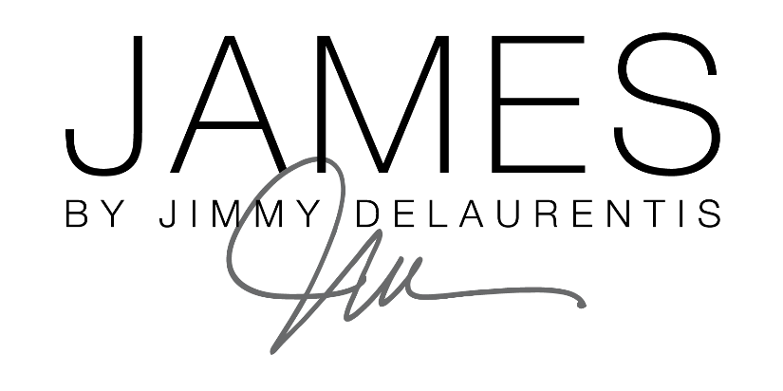

FOR IMMEDIATE RELEASE CONTACT: Kristin Hawkins
Steinreich Communications
212-491-1600
khawkins@scompr.com
JAMES BY JIMMY DELAURENTIS DOUBLES SIZE OF HIGH POINT SHOWROOM
ADDITIONAL SPACE PROVIDES ROOM FOR EXPANSION OF CUSTOM UPHOLSTERY LINE, PET SOFAS & LUXURY ACCESSORIES
PHILADELPHIA – JAMES by Jimmy DeLaurentis, a private label collection of luxurious upholstery, pet sofas, candles and premium accessories, has doubled the size of its InterHall showroom for the upcoming High Point Market. The new space will provide the company additional display area to showcase its newest collections designed with high-end interior designers and retailers in mind.
Located on the first floor of the International Home Furnishings Center (IHFC) in InterHall – space IH408 – the showroom will feature the company’s new Milan Collection of menswear-inspired upholstered furniture, coordinating pet sofas and premium teddy bear accessories.
“As we continue to expand our brand in the luxury market, a larger footprint was a logical next step and InterHall remains an ideal location for our line as it is the premier showcase of design-driven, luxury products at High Point Market,” said Jimmy DeLaurentis, founder and designer of JAMES by Jimmy DeLaurentis. “As an interior designer, I am driven by the desire to pull together an unprecedented look – whether that’s a lavish space for an A-list client or a showroom dedicated to debuting my new product lines – and this June in High Point, you can expect to see that same level of bold and memorable design in our new InterHall space.”
-more-
JIMMY DELAURENTIS SHOWROOM EXPANSION
TAKE 2-2-2-2

In addition to the new Milan Collection, the space will highlight upholstered furniture pieces from the Amalfi Collection, inspired by the vivid color palette of the Amalfi Coast and the Classic Collection, emoting luxury and class with timeless pieces that compliment any design aesthetic. An assortment of custom pet sofas – made with the same level of detail and quality as the furniture collections – will be on display, as well as a new line of luxury teddy bears.
The showroom will also feature an Assouline book pop-up boutique. A signature design element often used in interior spaces designed by DeLaurentis, Assouline creates unique, luxury, culture-centric books that are works of art in their own right. Books will be available for purchase within the showroom.
Blown glass by Joe Caraiti, award winning artist, craftsman and educator, will also be layered throughout the JAMES showroom and available for purchase. Caraiti’s collection includes bottles, decanters, lamps and tabletop objects inspired by the icons of great mid-century modern design. The one-of-a-kind pieces – all crafted by hand – have also become a key element in DeLaurentis’ design aesthetic.
A Philadelphia native and design trailblazer with more than 25 years of experience, Jimmy DeLaurentis is known for creating luxurious and memorable spaces through his unique design aesthetic that combines opulence with a touch of playfulness. After honing his craft on the creative team at Ralph Lauren, he propelled his career by becoming an entrepreneur, designing stunning homes and businesses for A-list clientele. In 2016, he saw a void in the market for custom, luxury home furnishings and accessories with an element of surprise and launched JAMES by Jimmy DeLaurentis, a private label collection of luxurious sofas, chairs, ottomans, custom pet sofas, luxury candles and a premium teddy bear line. For more information, visit jimmydelaurentis.com.
-30-

