HIGH POINT FURNITURE MARKET 2018
Design Center D729

ECLIPSE - Buffet
Design Giorgio Soressi

Eclipse is a buffet with an uncommon geometry. Its volume, underlined in the lower part by a convex line, seems to be suspended and at the same time marked by the rigor of the wide steel profile that frames it. An effect of solids and voids creates a dynamic visual effect, while two thin handles draw on the doors a graphic sign that emphasizes the contrast between materiality and lightness. Declined in three different types of wood essences, combined with as many noble metals, Eclipse is an element of furnishing with a strong identity, which reveals the manufacturing knowledge of Costantini Pietro and the high quality of materials.
It is also available in the console version, which conceals a large and useful sliding drawer.

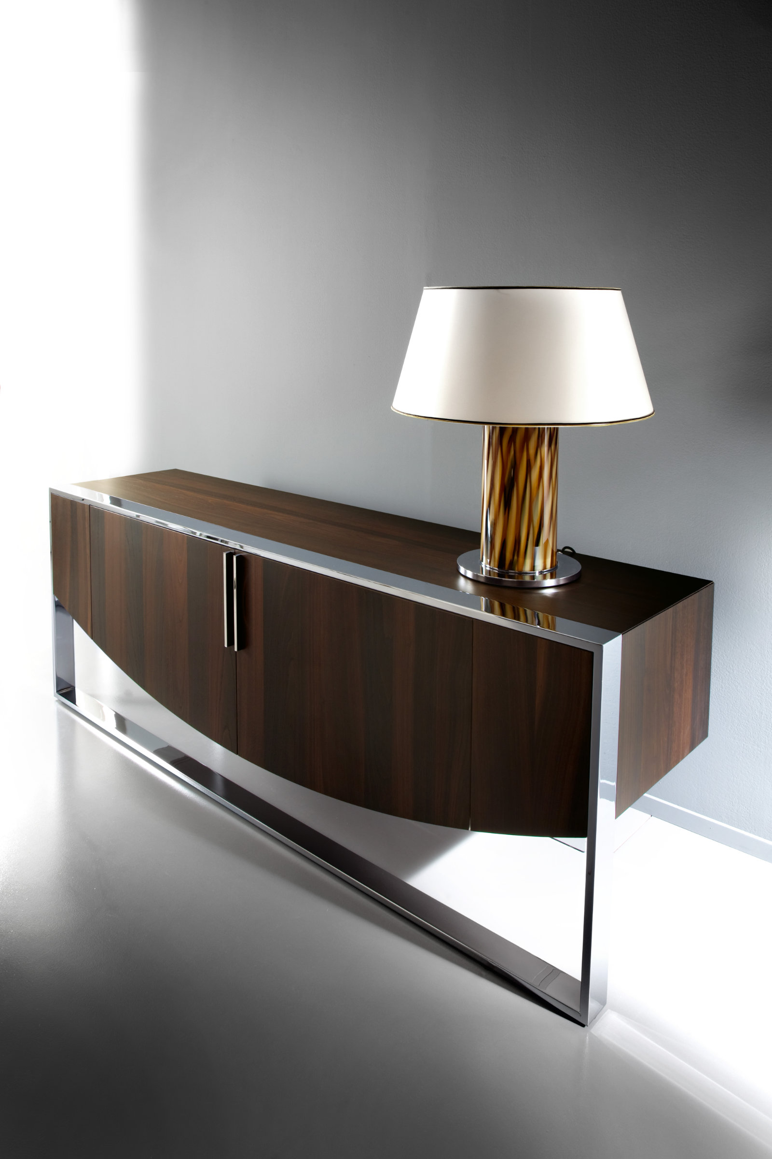

In photo: Eclipse, version in Castagno Toscano and structure in polished steel.

COSTANTINI PIETRO PRESS OFFICE
Adriana Cruciatti
acruciatti@caltpr.it
tel. +39 335 6853775

