For immediate release

CASTELLE’s 2019 Introductions To Include Traditional Design, Madeleine Collection

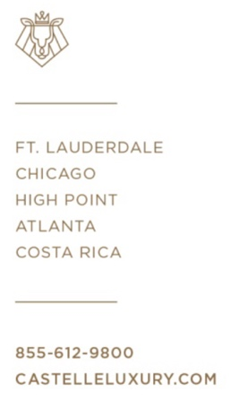
Ft. Lauderdale, Fla.- Award-winning designer and manufacturer of aluminum casual furniture Castelle is set to introduce for 2019 the Madeleine Collection and its traditionally defined style. Inspired by the appeal of a French country terrace, pieces within the Madeleine collection feature interconnected lines and curves across the chair back in addition to decorative turned-like cast aluminum legs.
“Our body of traditional collections has been the foundation of the CASTELLE brand,” said Mark Stephens, president, Castelle. “The addition of the Madeleine Collection builds upon this design style offering from Castelle and provides our retailers one more option suitable for coordinating with outdoor living areas anywhere.”

Reminiscent of fine indoor furnishings, Madeleine is available with a full complement of dining and lounge pieces. All feature durable multi-stage powder coat finishing. CASTELLE offers hundreds of options in finishes and fabrics as well as optional artisan applied antiquing. Madeleine’s crowning curve design is mirrored on the chair back cushions. Notched seat cushions allow for precise and defined comfort.

This traditional collection joins the robust slate of new introductions from Castelle for 2019 including additional custom and collaborative designs.

For more information about Castelle and luxury casual furniture, visit www.castelleluxury.com.
# # #

High Resolution images available. Contact: lrudd@pridefamilybrands.com
Pictured: Madeleine Collection Cushioned Dining

About CASTELLE®.
For over 40 years, CASTELLE has distinguished itself in the manufacturing of award-winning luxury casual furniture. Innovation, state of the art manufacturing, and superior quality products are the trademark of CASTELLE and the reason CASTELLE is recognized as a leader in the casual furniture industry. CASTELLE has been the recipient of multiple Manufacturing Leadership awards for the Cast Aluminum category.

