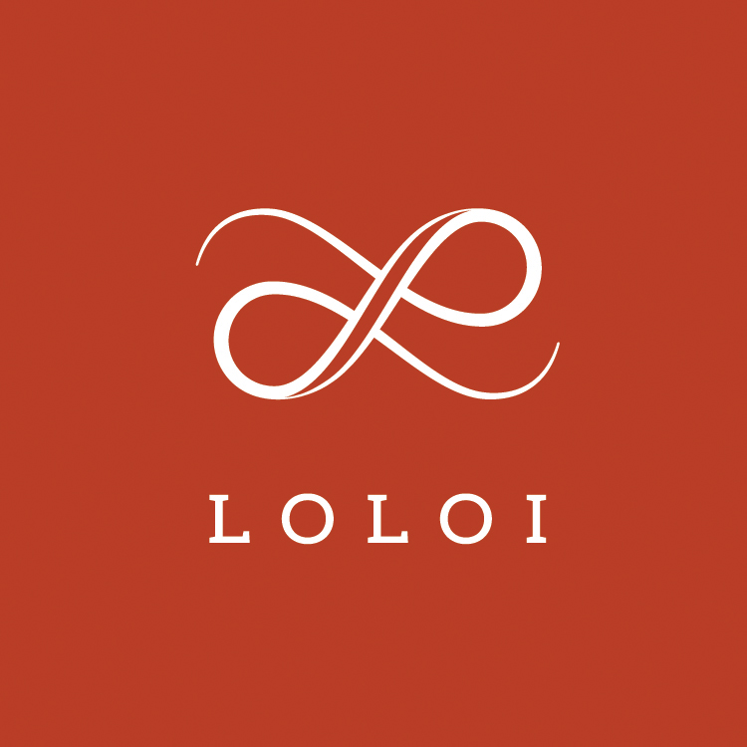
FOR IMMEDIATE RELEASE

CONTACT:
Jennifer Green
jgreen@burns-360.com
214-521-8596

Kenny G to Perform at Loloi’s 15th Anniversary Celebration
During Spring High Point Market

DALLAS (March 28, 2019) ― Loloi today announced that Grammy-award winning saxophonist Kenny G will perform at the company’s 15th anniversary celebration event during the Spring High Point Market this April.

A member of the 2016 Musician’s Hall of Fame™ Induction Class, Kenny G is one of the best-selling artists of all time. During the invitation-only event, the musician will entertain guests with a mix of his best hits, as well as songs from his most recent album Brazilian Nights.

“We’re so excited to have such a renowned artist join us to celebrate our 15th anniversary in style,” said Cyrus Loloi, principal. “Kenny G is an iconic musician whose instrumental music reaches across genres and generations, and has touched audiences around the globe. He’s the perfect fit for our celebratory evening.”

About LOLOI RUGS
Founded in 2004, LOLOI has become a fashion leader specializing in medium- to high-end area rugs in every style category, and a premium producer of textiles. Under the expert direction of area rug veteran Amir Loloi, the company has been inducted into the ARTS Awards Hall of Fame, winning five ARTS Awards for “Best Rug Manufacturer” in 2010, 2011, 2015, 2016 and 2017, one in 2012 for "Best Outdoor Manufacturer," and one in 2013 for “Green Manufacturer.” Its eight America’s Magnificent Carpets Awards and three Atlanta Visual Display Awards for sophisticated showroom design attest to the company’s commitment to innovation and quality.
LOLOI RUGS is headquartered in Dallas, with to-the-trade showrooms at: 295 Fifth Ave., New York, Showroom #1006 ● DallasMarketCenter, Suite 506 ● Las Vegas Market, Building B, Suite #480 ● High Point, IHFC Showroom #D-320 ● and AmericasMart, Atlanta, Showroom #4-D-2. For more information, visit: www.loloirugs.com. Call: (866) 362-1424.

